Unit 4 Yummy Foods
中国有句俗语叫“民以食为天”。确实，自古以来，中华民族在吃这件事情上就颇有造诣。在漫长的岁月中，勤劳智慧的华夏儿女利用丰富的物产创造出了无数令人垂涎的美味，让一件件朴素的食材完成了从食物到中华美食的转变。
餐桌上那一道道菜品不仅仅可以用来填饱肚子。这其中更承载着深厚的文化信息，不断诉说着独具魅力的中国故事，传播着独具特色的中国品味。
作为一张文化名片，越来越多的中华美食走出国门俘获了千千万万外国友人的心和胃，成为他们了解中国的一个窗口。

Unit Objectives
- Knowledge and skill:
Students should be able to talk about food and eating habits.
Students should grasp the new words and expressions in this unit.
Students should grasp the grammar about five basic sentence patterns.
Students should master the skills of memo writing.
- Feeling, attitudes, and values:
Students should be able to understand different eating culture and enjoy food.
- Ideological and Political Aims（思政目标）
Students should know the culture about Chinese food.
Enable students to understand different eating culture

Teaching Important Points
1 Master the following words and phrases:
immediately; panic; treat; liberally; cuisine; press; resist; combination；theme; magical; although; bunch; chase; in a snap; fly over; by far; wait for
2 Enable the students to understand different eating culture and enjoy food.
3 Ask the students to grasp the phrase of daily reception between the receptionist and customer.
4 Grasp the grammar of five basic sentence patterns.

Teaching Difficult Points
1 Improve the students’ reading ability of recognizing top sentences.
2 Ask the students to grasp how to write memo.

Teaching Aids
A multimedia classroom
The blackboard

Teaching Approach
Tasked-based; Group work

Teaching Procedures

Period 1

Part Ⅰ Lead-in
Exercise Ⅰ(steps) | Exercise Ⅱ(steps)
1 Provide some information to lead students to the topic “food”, teacher may invite some students to express their opinions about their favorite food.  2 Explain the new words and phrases in this part.  3 Play the video twice and ask the students to say something about the origins of the two foods below.  pricy /'praɪsɪ/ adj. 价格高的，昂贵的  delicacy /ˈdelɪkəsi/ n. 精美；美味佳肴  think of… as 把……看作  care about 关心；在乎；担忧；关怀 | 1 Explain the useful expressions in the table.  2 Set aside some time for students to work in groups to talk about their favorite food.  3 Invite some students to state their opinions.  4 Ask students to grasp these expressions.

Exercise Ⅱ
Sichuan cuisine （川菜） | street foods / local snacks （街边小吃，风味小吃）
mouthwatering（令人垂涎的，美味的） | tasty （美味的，可口的）
flavorful;（可口的） | fresh （新鲜的）
appetizing （开胃的，促进食欲的） | luscious （甘美多汁的，美味的）
spicy/hot（辛辣的） | vinegary （酸的）
sweet （甜的） | bitter （苦的）
greasy （油腻的） | tender （柔软的）

思政拓展：中国美食到底有多好吃？
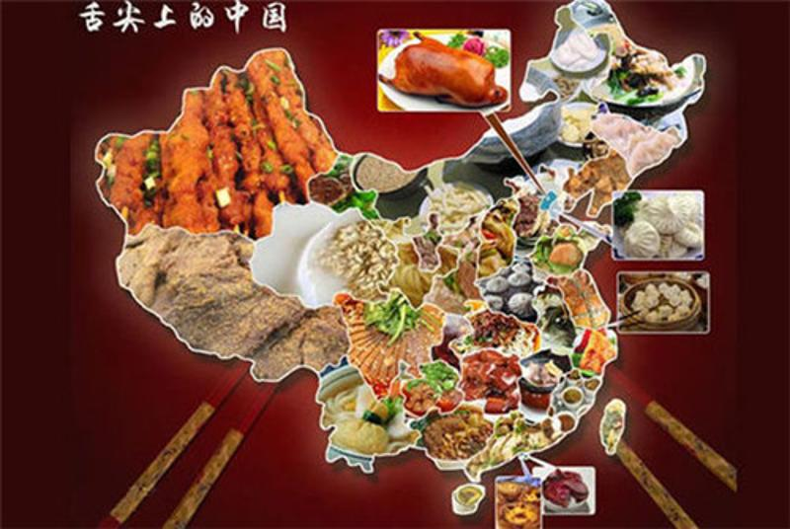
中国饮食追求味道谐调和中，但不同地方的人却有着千差万别的口味。
这是因为中国饮食文化里具有明显的地域性差别。一个地方饮食文化的建立与它当地的物产、气候、历史、文化、宗教等因素都密切相关。无论一个地域的饮食口味怎样变，都隐含着中国思想文化的影子。
https://mp.weixin.qq.com/s?src=11&timestamp=1636638368&ver=3430&signature=9VEK1YhnqgVIl*7ElDtCni02xFrqJ4O7t*i4LRYGeVhAVofDy9BH-b--P1HHQmtzedhOswRGQGa-vYQMxiIkzR3F5WBqpWC*wwV*HwohZHjpb2B*py4uEct-MPIPNOnE&new=1

Assignments
- 100% of students should grasp new words and phrases in ExerciseⅠ .
- 60% of students can express their opinions about their favorite food.
30% of students can make more sentences based on the knowledge they have learned; they can talk about their favorite food.
- .

Part Ⅱ Listening and Speaking

Exercise I

Steps
1 Lead the students to read the new words and expressions and explain their meanings.
2 Ask the students to listen to the recording twice, and then fill in the blanks.
3 Check the answers.

Words and Phrases
1 make out 辨认出；理解；假装
e.g. I heard the voices, but couldn't make out what they were saying.
我听到有声音，却听不清他们在说些什么。
2 replace /rɪˈpleɪs/ v. 替换；代替；把……放回原位；（用……）替换
e.g. Teachers will never be replaced by computers in the classroom.
课堂上电脑永远不会取代老师。
~ sb. / sth. with / by sb. / sth.（用……）替换；（以……）接替
e.g. He will be difficult to replace when he leaves.
他离开后，他的位置很难有人接替。
Teachers will never be replaced by computers in the classroom.
课堂上电脑永远不会取代老师。
3 refund /ˈriːfʌnd/ v. 退还；归还或偿还
e.g. Dissatisfied customers can return the product for a full refund.
顾客如不满意可以全额退货。
4 calm down （使）平静，镇静，安静；（使）平静下来
e.g. He took a few deep breaths to calm himself down.
他深深地吸了几口气，使自己平静下来。
5 recommend /ˌrekəˈmend/ v. 推荐；劝告；托付
e.g. Can you recommend a good hotel? 你能推荐一家好的饭店吗？
6 specialty /ˈspeʃəlti/ n. 特色菜；招牌菜
e.g. regional specialties 地方特产
7 dressing /ˈdresɪŋ/ n.（拌制色拉用的）调料
e.g. Fry remaining peppers, adding a little more dressing if necessary.
用油炸一下剩下的辣椒，如果需要再加点调味汁。

Exercise Ⅱ

Steps
1 Explain the useful expressions about order making.
* Hello, this is…restaurant. What can I do for you?  您好，这里是……饭店。能为您做点什么吗？ | * I’d like to order…  我想预定……
* How many shares would you like?  您几位？ | * Do you need to avoid any ingredients?  您有什么忌口吗？
* Do you need anything else?  您还需要别的什么吗？ | * I’m sorry that… all have been sold today.  非常抱歉，……已经售完。
* You have ordered…. Anything missed?  您已预定……，有遗漏的吗？ | * May I pay the bill with credit card?  我可以用信用卡支付吗？
* When would you like your dishes to be delivered?  请问什么时候为您配送？ | * Your food will be delivered right on time.  您的食物将会准时配送。
2 Play the sample video twice.
3 Set aside some time for students to work in groups to organize their own scene according to the given situation and sample video.
4 Invite one or two groups to perform their scene.

Exercise Ⅲ

Steps
1 Introduce the song simply and let the students enjoy it.
《Chicken Fried》由美国乡村乐队——柴克布朗乐团演唱。这首歌让人联想到家里餐桌上令人垂涎欲滴的美食，也能体现出对家庭和生活的爱。你想念家乡的食物吗？
2 Ask the students to fill in the blanks.
3 Check the answers.
Assignments
- 100% of students know how to use the useful expressions about order making (录音或视频).
- 70% of students be able to organize their own scene according to the given situation and sample video.(录音或视频).

Period 2

Part Ⅲ Reading

Teaching Focus
 | Text A Intensive Reading | Text B Extensive Reading
Theme | Panic at the Dinner | Foods
Words and Phrases | immediately; panic; treat; liberally; cuisine; press; resist; combination；theme | magical; although; bunch; chase; in a snap; fly over;  by far; wait for.
Text A Intensive Reading

Steps
1 Lead students to read the new words and phrases in Text A and explain their meanings.
2 Ask the students read the questions in exerciseⅡ. And give them 15 minutes to read the text.
3 Discuss the whole text with the students while explaining the main idea of each paragraph.
4 Analyze some difficult sentences and language points.
5 Ask the students to finish the exerciseⅠand check the answers.
6 Ask the students to read the 7th paragraph and try to recite after class.
7 Ask the students to finish other related exercises in Text A.
8 Check the answers.

Pre-Reading Discussions
This text is a story describing how the author treated her best friend, who comes afar from another city, a big dinner. The author chose the restaurant carefully, and the dinner was a successfully one, including the seat, the restaurant environment and each small dishes. Lead the students to the text by asking the pre-reading questions:
Have you ever treated a friend from other cities?
What impresses you most when you treated your friends?

Text Structure
Parts | Paras. | Main Ideas
One | Paras. 1~3 | Taryn calls me that she would come to see me, and I was overjoyed and worrying.
Two | Paras. 4~6 | The wonderful dinner time.
Three | Para. 7 | I learnt that having a dinner party not only can we share delicious food, but also can get closer to friends.

Detailed Study
1 I was immediately overjoyed. And then I panicked. (Para. 1)
immediately /ɪˈmiːdiətli/ adv. without delay 立即；马上；即刻
e.g. She answered almost immediately. 她几乎立刻就回答了。
overjoyed /ˌəʊvəˈdʒɔɪd/ adj. extremely happy or pleased 非常高兴；欣喜若狂
~ at sth. / ~ to do sth.
e.g. He was overjoyed at my success. 我的成功使他欣喜若狂。
We were overjoyed to hear their good news.
听到他们的好消息，我们都大喜过望。
panic /ˈpænɪk/ v. to suddenly feel frightened so that you cannot think clearly and you say or do sth. stupid, dangerous, etc.; to make sb. do this （使）惊慌，惊慌失措
e.g. I panicked when I saw smoke coming out of the engine.
我看见发动机冒烟时，吓得手足无措。
Language Point:
“I was immediately overjoyed” 一句中 I 主语后直接加谓语 be overjoyed. 构成S+V结构，此时谓语常为不及物动词。
2 I was panicking because I knew that I had to treat her to spectacular New York dinners. (Para. 1)
treat /triːt/ v. to pay for sth. that sb. / you will enjoy and that you do not usually have or do 招待；款待；请（客）；买（可享受的东西）
~ sb. to sth.
e.g. She treated him to lunch. 她请他吃午饭。
spectacular /spekˈtækjələ(r)/ adj. very impressive 壮观的；壮丽的；令人惊叹的
e.g. spectacular scenery 壮丽的景色
There was a spectacular sunset last night. 昨晚的日落非常壮观。
Language Point:
“I had to treat her to spectacular New York dinners” I 作为句子的主语，treat是谓语，间接宾语her，直接宾语为dinner，构成典型的S+V.+In O+D O 的主谓宾句型。
3 I hope you don’t think I was being hard on myself. (Para. 2)
be hard on 严格对待（批评）某人；对某人不公平；不客气
e.g. Don’t be hard on this little girl. 别对这个小姑娘这么凶。
4 Mémé is a Mediterranean restaurant, but its menu of small plates and liberally spans the cuisines of countries from Italy to Morocco. (Para. 4)
liberally /'lɪbərəlɪ/ adv.（政治、经济上）自由地，开明地；支持（社会、政治或宗教）变革地
e.g. He was liberally educated. 他受过开明的教育。
span /spæn/ v. to include a large area or a lot of things 包括（广大地区）；涵盖（多项内容）
e.g. The operation spanned nine countries and resulted in 200 arrests.
这次行动涉及九个国家，逮捕了200人。
cuisine /kwɪˈziːn/ n. the food served in a restaurant (usually an expensive one) （通常指昂贵的饭店中的）饭菜，菜肴
e.g. The hotel restaurant is noted for its excellent cuisine.
这家饭店的餐厅以美味佳肴闻名遐迩。
Language Point:
“Mémé is a Mediterranean restaurant” 该句中，Mémé为主语，is为系动词，与后面表语Mediterranean restaurant 构成S+V（常为系动词）+P（表语）的基本句型，该句型通常表示状态，变化等。
5 The French posters and a high, pressed tin ceiling helped the space feel warm and cozy. (Para. 4)
press /pres/ v. to push sth. closely and firmly against sth.; to be pushed in this way
（被）压，挤，推，施加压力
~ sth. / sb. / against sth.
e.g. She pressed her face against the window. 她把脸贴在窗子上。
cozy /'kəʊzɪ/ adj. warm, comfortable and safe, especially because of being small or confined 温暖舒适的（尤指狭小的室内地方）
e.g. I felt warm and cozy sitting by the fire. 坐在炉火旁，我感到暖和舒服极了。
6 Taryn and I are on the same page when it comes to food. (Para. 5)
when it comes to 当提到……；当涉及到……
e.g. When it comes to expressing himself he is no shrinking violet.
他在表达自己的想法时毫不羞怯。
7 How could we resist the combination appetizer platter, laden with beets and the hummus and pickled carrots? (Para. 5)
resist /rɪˈzɪst/ v. to refuse to accept sth. and try to stop it from happening 抵制；阻挡
e.g. They are determined to resist pressure to change the law.
他们决心顶住要求改革法律的压力。
combination /ˌkɒmbɪˈneɪʃn/ n. two or more things joined or mixed together to form a single unit 结合体；联合体；混合体
e.g. What an unusual combination of flavors! 多么与众不同的混合风味啊！
8 Another victory was the truffle gnocchi in cream sauce. (Para. 6)
victory /ˈvɪktəri/ n. success in a game, an election, a war, etc. 胜利；成功
~ over / against sb. / sth.
e.g. a decisive / narrow victory 决定性的胜利/险胜
the team’s 3–2 victory against Poland 该队以3:2战胜波兰队
Language Point:
“Another victory was the truffle gnocchi in cream sauce”。句中Another victory为主语， was为系动词，the truffle gnocchi in cream sauce为表语部分，也是一个典型的主系表句型。
9 As an added bonus, the gnocchi came out in a small ceramic bowl. (Para. 6)
bonus /ˈbəʊnəs/ n. an extra amount of money that is added to a payment, especially to sb’s wages as a reward 奖金；红利
e.g. Being able to walk to work is an added bonus of the new job.
能够步行去上班是这份新工作额外的好处。
10 With small plates, you get the fun of sharing food with the comfort of knowing that everyone will like something. (Para. 7)
share sth. with sb. 与……分享、合用；把（自己的感受）告诉（某人）
e.g. She would have liked to share with him the joy she had felt.
她愿意和他一起分享曾经享受过的快乐。

Text B Extensive Reading

Steps
1 Lead the students to read the new words and phrases in Text B and explain their meanings.
2 Ask the students to read the questions in Reading Comprehension and then give them 15 minutes to read the text.
3 Ask the students to finish the exercises in Reading Comprehension.
4 Check the answers

How to Use the Reading Skills
Examples from Text B:
1 Pizza is the best food on the planet, as it’s really good and I just love the taste.（Para.4 这句话为该段的首句，也是该段的主题句。句中表达出披萨是作者眼中最为美味的食物，非常喜欢它的味道。作为段落的中心句，提携，概括段落的主要意思，也就可以推断出该段都在表达对披萨的喜爱，以及披萨的味道等。这就是主题句所起的作用。）
2 Food is an escape to yummy paradise. （Para.6 这句话位于段尾，意思是“食物可以带你去到享乐的天堂”。主题句也可以出现在段尾，总结概括段落的大意。）

Detailed Study
1 Food is magical like a big unicorn flying over a rainbow of multicolored goldfish crackers. (Para. 1)
magical /ˈmædʒɪkl/ adj. containing magic; used in magic 有魔力的；奇妙的，神奇的
e.g. Her words had a magical effect on us. 她的话对我们有一种魔力般的作用。
fly over 飞过；飞到另一个地方去
e.g. Planes fly over all day. 整天都有飞机飞过。
2 Sometimes I can eat a whole can of Pringles and it is always gone in a snap. (Para. 1)
a can of 一罐
e.g. He took a can of beer from the fridge. 他从冰箱里取出一罐啤酒。
in a snap 立刻，马上
e.g. I’ll finish the letter in a snap. 我马上就能把这封信写完。
3 I get so mad because I really like Pringles and I can’t even savor the Pringles because I ate them all. (Para. 1)
savor /'seɪvə/ v. 给……加调味品；使有风味；品尝；欣赏
e.g. I’m just thinking he should savor his next birthday cake.
我只是说他应该好好品尝一下明年的生日蛋糕。
4 I can’t resist the chips, French fries, pizza, oh, the glorious piece of pizza, although they may be unhealthy. Pizza has to be, by far, my favorite food. (Para. 2)
although /ɔːlˈðəu/ conj. used for introducing a statement that makes the main statement in a sentence seem surprising 虽然；尽管；即使
e.g. Although the sun was shining it wasn’t very warm. 尽管太阳高照，却不很暖和。
by far 到目前为止；……得多；更；尤其
e.g. The economy is the number one issue by far. 到目前为止，经济是头等大事。
5 I really like breakfast foods because there is a lot of choices like, pancakes, waffles, toast, cereal and a bunch of others that I can’t remember. (Para. 3)
a bunch of 一群；一束；一堆
e.g. We did a bunch of songs together. 我们一起唱了很多首歌。
a bunch of red rose 一束红玫瑰
6 Like if a giant mutant piece of pepperoni pizza chased you around the school and ate all of the kids, they all scream AAAHHH!! (Para. 5)
chase around 向某方向急奔
e.g. She couldn’t study with the children chasing around the house.
孩子们在房子里跑来跑去，她没法学习。
scream /skriːm/ v. to give a loud, high cry, because you are hurt, frightened, excited, etc. （因伤痛、害怕、激动等）尖叫
~ in / with sth.
e.g. The kids were screaming with excitement. 孩子们兴奋地喊叫着。
8 Sometimes you have to wait for the good things in life like when, you get out of school and you finally have freedom from homework and school. Food is an escape to yummy paradise. (Para. 6)
wait for 等待；观望形势后再作决定
e.g. Check us in at the hotel and wait for my call.
去宾馆替我们办理好入住手续，然后等我的电话。
get out of 摆脱；逃避
e.g. In order to get out of the peak-hour traffic, we must start early.
我们得早点儿动身以避开交通高峰期。

什么样的美食最能安抚人心？
英国作家扶霞·邓洛普就曾在她的《鱼翅与花椒》中写过类似的感受：“食物带来的愉悦让他们在人生和事业遭受挫折时找到了一处避难所。生活是苦的，食物却能带来一丝暂时的甜。”
想让生活有质感，想让日子过得有滋味，并不一定需要多么繁复的仪式。一口简单的吃食，有时候就能够满足我们的身心所需。正是因为看到这一点，必胜客沉下心，站在一个更高、更深远的基点上，去观察大众口味的变化，并发掘中国传统，他们将优良的特质继承下来，并把自己最出众的餐饮意涵注入其中。
https://mp.weixin.qq.com/s?src=11&timestamp=1636722499&ver=3432&signature=TCFofpXXxc7z*twkg0djNb0hDWYipPrB1t1NeBG6AZcoOKvjK3CUJ7m3qvQgOXXwqPjaOCFa8R8SVIn*aNX1BOd6u*YEzyic28XhiTDaeqZwml6gX-8ZumWXYYgFgao1&new=1

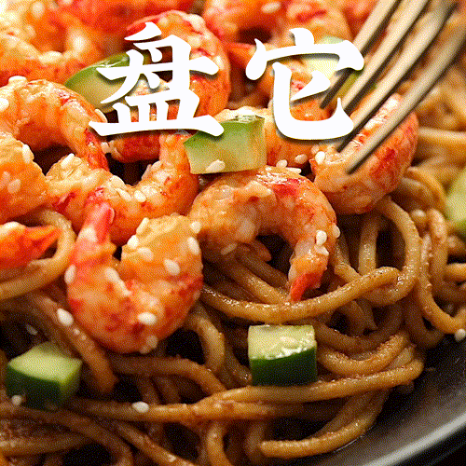
Assignments:
1. Know the skills and improve reading ability（思维导图）

Period 3

Part Ⅳ Grammar

Steps
1 Explain the details of the sentence patterns.
2 Ask students to finish the exercises.
3 Check the answers.
Assignments
- 100% of students grasp what are the five sentence patterns.
- 80% of students know how to use the sentence patterns correctly.

Part Ⅴ Applied Writing

Steps
1 Introduce what is Memo and in what circumstances it will be used.
Memo is short for memorandum. It is a written message sent by one person to another or a group of people within the same organization. It is a simple and efficient message that is used to remind of or draw someone’s attention to certain matters.
2 Explain the main points in Memo.
Title
Date: current date
To: reader’s name and job title
From : writer’s name and job title
Subject: what the memo is about, highlighted in some way
Body: detailed information
Closing remarks: building positive relationships with reader
- Ask the students to read the sample and to complete the practice by themselves.
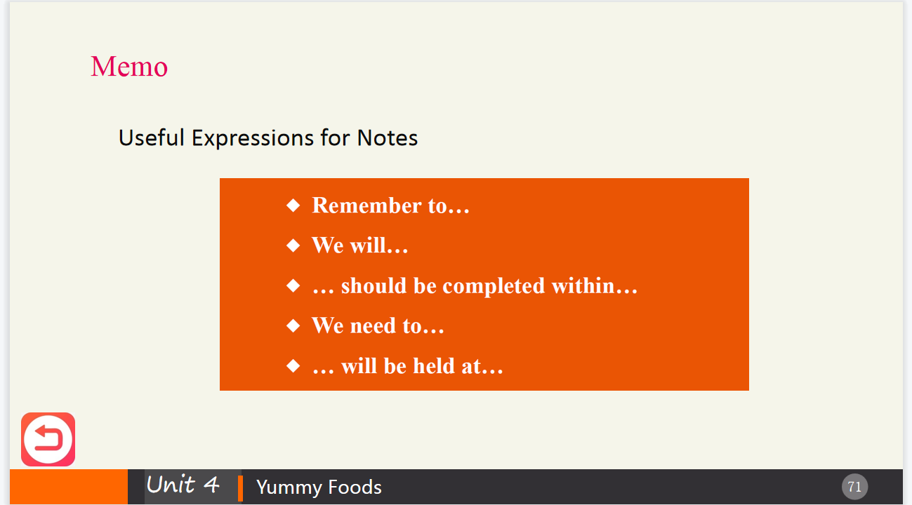
Assignments
- 100% of students can get the main points in Memo.
- 80% of students can write a Memo required independently.

Period 4

Part Ⅵ Watching & Performing

Steps
1 Introduce the main plot of the movie.
《燃情主厨》是在2015年，由约翰·威尔斯导演的一部美剧。剧情主要讲述了亚当·琼斯——米其林餐厅如日中天的当红大厨，因浪荡度日，毁了前程。然而受挫的他深信天分并未衰减，于是毅然回到伦敦，卷土重来，找来一群年轻厨师，开一家史无前例的超级餐厅重振雄风。在这期间，他明白了这件事是他无法独自完成的，他应该相信他的助理和朋友们，为他们做饭，并彼此关心着。
2 Play the movie clip.
3 Ask students to imitate the movie clip.
4 Explain the useful expressions for receptionists and customers when visiting a company
5 Ask the students to make their own dialogue and perform it in groups.
6 Ask the students to appreciate the lines from: The Last Jedi.

