Unit 3 Amazing Travel
“读万卷书，行万里路。”读书是一种纸上的旅行，旅行是一种路上的读书，谁都无法代替谁。当用开放心态去触摸未知世界时，生活会变得充实而灵动，这是一种头脑的旅行。
泰戈尔说：“旅人叩过每个陌生人的门/才找到自己的家/人只有在外面四处漂泊/才能到达内心最深的殿堂。”一路走来，欣赏过那么多壮丽的景色，了解过那么多奇特的风情，接触过那么多陌生的脸孔，发生过那么多感人的故事，历经过那么多艰苦的磨练，不为炫耀，不为猎奇，更非走向虚无，而是更加认识自己。

Unit Objectives
- Knowledge and skill:
Student should acquire the new words and expressions.
Students should grasp the grammar of verbs and articles.
Students should master how to write notes.
Students should know how to describe a trip and scenery
- Feeling, attitudes, and values:
Students should know the meaning of travel, and enjoy the beauty of nature.
- Ideological and Political Aims（思政目标）
Students should know the meaning of travel.
Enable students to enjoy the beautiful scenery, which may help to stimulate learning interest and enthusiasm

Teaching Important Points
1 Master the following words and phrases:
reality, unique, uphold, sink, shed, local, resort, fellow, fancy, retire, limit, energy, threaten, regularly, support, go on a trip, be familiar to, shed a light on, settle down
2 Enable the students to understand the meaning of travel, and to enjoy the beauty of nature, what’s more, to increase the love of life.
3 Ask the students to grasp the phrase of booking tickets between the receptionist and customer.
4 Grasp the grammar of verbs and articles.

Teaching Difficult Points
1 Improve the students’ ability of guessing the meaning of words by synonym or near-synonym.
2 Ask the students to grasp how to write notes.

Teaching Aids
A multimedia classroom
The blackboard

Teaching Approach
Tasked-based; Group work

Teaching Procedures

Period 1

Part Ⅰ Lead-in
Exercise Ⅰ(steps) | Exercise Ⅱ(steps) | Exercise Ⅲ (steps)
1 Show some pictures about travel and play the video, ask the students to enjoy the beautiful scenery, which may help to stimulate learning interest and enthusiasm.  2 Explain the new words and expressions in the textbook.  3 Invite some students to show their opinions about the question in exerciseⅠ  spend one’s holiday 度假  beyond one’s imagination 超乎想象；难以想象  novel /ˈnɒvl/ adj. 新颖的；与众不同的；珍奇的 | 1 Explain the words and expressions in the table.  2 Play the video twice and ask the students to fill in the blanks.  3 Check the answers.  4 Ask students to grasp these expressions.  option /ˈɒpʃn/ n. 可选择的事物  thirst to 渴望得到  wander /ˈwɒndə(r)/ v. 漫游；游荡；  make a plan 做计划  free /friː/ adv. 脱离束缚，行动不受限制地  forever 永远；不断地  drive /draɪv/ v.迫使；驱使 | 1 Introduce some expressions and words concerning travel.  2 Set some time for students to discuss in groups about the questions and then invite some to show their opinions.

思政拓展：疫情中难以出境游，中国人都去哪旅游了？


在全球因疫情陷入恐慌，各国还在采取严格封闭管控的背景下，中国游客国内出游能够依然热度不减，与许多感染人数居高不下、饱受频频封锁和旅行限制之苦的西方国家形成鲜明对比。
这一切都是中国政府正确响应指导以及全国人民团结一心高效抗疫的必然结果。在疫情防控常态化的今天，已不见当初病毒带来的荒凉和肃杀，而是热闹一片的繁荣景象。
https://mp.weixin.qq.com/s?src=11&timestamp=1636723221&ver=3432&signature=pD6lot1xEG7ntSn6InrIQ-CCHmE*bl9iDh9Dkypa0ybkdohY9Rql3G6CE64FAFtJymgQ86If9MRG7T3fpx5YDntctQP68EqwxJyqeqLB3F5QQNiLb4kuqx-qwY6gL1bG&new=1

Assignments
- 100% of students should Explain the new words and expressions
- 60% of students should show their opinions about the question“Which kind of places do you want to travel to and why”.
- 30% of students can make more sentences based on the knowledge they have learned; they can search for more information about reservation .

Part Ⅱ Listening and Speaking

Exercise I

Steps
1 Lead the students to read the new words and expressions, and then explain their meanings.
2 Let the students listen to the recording twice, and then fill in the blanks.
3 Check the answers.

Words and Phrases
1 typical /ˈtɪpɪkl/ adj. 典型的；有代表性的
e.g. This meal is typical of local cookery. 这是有当地风味的饭菜。
2 souvenir /ˌsuːvəˈnɪə(r)/ n. 纪念物；纪念品；（度假时买回来送人的）礼物
e.g. I bought the ring as a souvenir of Greece. 我买了一枚戒指，留作对希腊的纪念。
3 scarf /skɑːf/ n. 围巾；披巾；头巾
e.g. I bought a great tie-dyed silk scarf. 我买了条非常好的扎染丝巾
4 discount /ˈdɪskaʊnt/ n. 折扣；打折
e.g. They were selling everything at a discount. 他们销售的所有商品都打折。
5 reservation /ˌrezəˈveɪʃn/ n. 预订；预约
e.g. I’ll call the restaurant and make a reservation . 我要给饭店打个电话预订座位。
6 registration /ˌredʒɪˈstreɪʃn/ n. 登记；注册；挂号
e.g. Another driver managed to get the registration number of the car.
另一名司机看清了该车的车牌号。
7 receptionist /rɪˈsepʃənɪst/ n. 接待员
e.g. The receptionist recognized him at once. 接待员一眼就认出他了。
8 traveler’s check 旅行支票
e.g. I’d like to cash a traveler’s check please. 我想兑换旅行支票。

Exercise Ⅱ

Steps
1 Explain the useful expressions about reservation.
* What can I do for you？  我能为你做点什么呢？ | * I have made a room reservation here.  我在这里预定了一个房间。
* May I have your name, please?  请问，您叫什么？ | * I’m sorry, we don’t have your reservation.  抱歉，这里没有您的预定。
* I’m sure I’ve made the call.  我确定我电话预定过了。 | * I made the reservation call on May 7th.  我在5月7号电话预定的。
* Let me check that for you.  我来为您查找一下。 | * Sorry, there’s our mistake.  抱歉，是我们的问题。
* To make up for you, we can give you a half discount for your room.  为了予以补偿，我们会为您的房间打五折。 | * That’s great! May I pay in cash or by credit card?  那太好了，我是现金支付还是信用卡支付？
2 Play the sample dialogue twice.
3 Set aside some time for students to work in groups to organize their own scene according to the given situation and sample dialogue.
4 Invite one or two groups to perform their scene.

Exercise Ⅲ

Steps
1 Introduce the song simply and let the students enjoy it.
《Sunday Trip》是由中国乐队拖特巴士大乐团创作并演唱。这首歌为大家描绘了一幅短途旅行的温馨画面，听后让人觉得惬意、放松。如果你没有足够的时间来一次长途旅行的话，那么考虑一次精致、美妙的周末旅行吧！
2 Ask the students to fill in the blanks.
3 Check the answers.

Assignment
- 100% of students know the meanings about the new words and expressions. (录音或视频).
- 70% of students be able to use the expressions about reservation.(录音或视频).

Period 2

Part Ⅲ Reading
Teaching Focus
 | Text A Intensive Reading | Text B Extensive Reading
Theme | How Travel Transformed me | Backpacking Around the World at 72
Words and Phrases | reality, unique, uphold, sink, shed, local, resort, fellow, fancy | retire, limit, energy, threaten, regularly, support

Text A Intensive Reading

Steps
1 Lead students to read new words and phrases in Text A and explain their meanings.
2 Ask the students to read the questions in exerciseⅡ. And give them 15 minutes to read the text.
3 Discuss the whole text with the students while explaining the main idea of each paragraph.
4 Analyze some difficult sentences and language points.
5 Ask the students to finish the exerciseⅠand check the answers.
6 Ask the students to read the 8th paragraph and try to recite it after class.
7 Ask the students to finish other related exercises in Text A.
8 Check the answers.

Pre-Reading Discussions
This text is about a trip story to Tibet of the author and his family. In the text, the author describes the beautiful scenery in Tibet. And most importantly, this trip shed a new light on the world and the life. Lead the students to the text by asking the pre-reading questions:
Have you ever travelled to other places?
What do you think is the most valuable thing in your trip?

Text Structure
Parts | Paras. | Main Ideas
One | Paras. 1～3 | Introduce the outline of the trip.
Two | Paras. 4～6 | Show the first Tibetan the author met, and her story.
Three | Paras. 7～9 | What the author learnt from the Nobu’s story.

Detailed Study
1 Recently I went on a trip to Tibet with my family. (Para. 1)
go on a trip 旅行
e.g. I would prefer buy computer rather than go on a trip.
我宁愿花钱买台电脑也不去旅游。
go on a holiday＝go on a vacation＝go on a tour＝go on a journey
思政拓展：
外交部：红色旅游是共产党带领人民创造新生活的成功实践！附100个红色旅游景区
红色旅游是中国共产党带领人民创造新生活的成功实践。亲临革命圣地，了解中国共产党由小到大、由弱到强的伟大历程，就不会忘记我们是从哪里走来的，就能从历史中汲取前进的智慧和力量。
https://mp.weixin.qq.com/s?src=11&timestamp=1636724369&ver=3432&signature=BMthqJBASmdeS5SZ3cJwOJH1mK9HiRhjusz9XKvA2dJ5JeQtItE1W*QD-lO0QuED8t7y0iB3fXTvxHI-i8SWS80-tJP8v7YYmfrdeSEt8u1Jeua3OZDDRggi1i2uq*kJ&new=1

2 The trip really opened my eyes to a completely different reality. (Para. 1)
open one’s eyes… 打开眼界；（使人）长见识（或开眼界、认清事实）
e.g. Travelling really opens your eyes to other cultures.
旅游真的能使人开阔眼界，认识其他文化。
reality /riˈæləti/ n.
the true situation and the problems that actually exist in life, in contrast to how you would like life to be 现实；实际情况
e.g. She refuses to face reality . 她不肯面对现实。
in reality 事实上
e.g. He looks like a teacher, but in reality he is not.
他看起来像个老师，但实际上并非如此。
3 Tibet has its own colors and its own unique traditions that are still upheld after thousands of years. (Para. 2)
unique /juˈniːk/ n. being the only one of its kind 唯一的；独一无二的
e.g. Everyone’s fingerprints are unique. 每个人的指纹都是独一无二的。
uphold /ʌpˈhəʊld/ v. to support sth. that you think is right and make sure that it continues to exist 支持，维护（正义等）
e.g. We have a duty to uphold the law. 维护法律是我们的责任。
4 I could go on and on about how wonderful and interesting Tibet is, but the highlight of my trip was the Tibetans I met on my journey and their unique stories. (Para. 3)
on and on 继续不停地；不断地
e.g. The old men talked on and on. 这几个老头喋喋不休。
highlight /ˈhaɪlaɪt/
n. the best, most interesting or most exciting part of sth. 最好（或最精彩、最激动人心）的部分
e.g. The highlights of the match will be shown later this evening.
比赛最精彩的片段将于今晚稍后播出。
v. to emphasize sth., especially so that people give it more attention 突出；强调
e.g. The report highlights the major problems facing society today.
报告特别强调了当今社会所面临的主要问题。
5 I learned that she came from a small village close to the border of Nepal, to Lhasa to study English before eventually becoming a tour guide. (Para. 4)
border /ˈbɔːdə(r)/
n. the line that divides two countries or areas; the land near this line 国界；边界；边疆；边界地区
e.g. Denmark’s border with Germany 丹麦和德国的国界线
v. to share a border with another country or area 和……毗邻；与……接壤
e.g. The large garden is bordered by a stream. 大花园紧临着一条小溪。
eventually /ɪˈventʃuəli/ adv. at the end of a period of time or a series of events 最后；终于
e.g. Our flight eventually left five hours late. 我们的班机最终晚了五个小时起飞。
6 I’ve only seen lakes; is the sea similar to lakes? (Para. 4)
be similar to 与……相似；类似于
e.g. Your output should be similar to Listing 2. 您的输出应该与请单2所示类似。
7 I knew how nice it felt to stand on wet sand and slowly sink into it. (Para. 5)
sink /sɪŋk/ v. to go down below the surface or towards the bottom of a liquid or soft substance 下沉；下陷；沉没 （过去式：sank；过去分词：sank）
e.g. The ship sank to the bottom of the sea. 船沉入海底。
8 The sea is so familiar to me, yet I couldn’t find words to help Nobu picture what the sea is like. (Para. 5)
be familiar to… 被某人熟悉；对某人来说是熟悉的
e.g. My argument had a logic that be familiar to economists.
经济学家对于我论点背后的逻辑会很熟悉。
be familiar with… 熟悉；认识
e.g. His fans would already be familiar with Caroline.
他的崇拜者们肯定已经很熟悉卡罗琳了。
picture /ˈpɪktʃə(r)/ v. to imagine sb. / sth.; to create an image of sb. / sth. in your mind 想象；设想；忆起
e.g. I can still picture the house I grew up in. 我还能回忆起我童年时住的那座房子。
9 In that simple, short conversation, I realized how lucky I am to have seen a lot of what the world has got to offer. (Para. 6)
realize /ˈriːəlaɪz/ v. to understand or become aware of a particular fact or situation 理解；领会；认识到；意识到
e.g. I didn’t realize (that) you were so unhappy. 我没有察觉到你那么不开心。
10 Meanwhile, here on this side of the world, there’s someone who has no idea what other places look like or how they feel because they just couldn’t afford these experiences. (Para. 6)
meanwhile /ˈmiːnwaɪl/ adv. while sth. else is happening 同时；与此同时
e.g. I continued working, meanwhile, he went out shopping.
我继续工作, 这期间他出去买东西。
for the meanwhile 一会儿；暂时
e.g. We need some new curtains, but these will do for the meanwhile.
我们需要一些新的窗帘，但这些暂时还可以用。
in the meanwhile 在此期间；与此同时
e.g. I hope to go to medical school eventually. In the meanwhile, I am going to study chemistry. 我希望最终能上医学院，这期间我打算学化学。
afford /əˈfɔːd/ v. (usually used with can , could or be able to , especially in negative sentences or questions 通常与can、could或be able to连用，尤用于否定句或疑问句) to have enough money or time to be able to buy or to do sth. 买得起；（有时间）做，能做
Language Point:
afford sth.
e.g. Can we afford a new car? 我们买得起一辆新车吗？
afford to do sth.
e.g. We can’t afford to go abroad this summer. 今年夏天我们没有足够的钱去国外。
11 Nobu’s story shed a whole new light on the world we live in. (Para. 7)
shed /ʃed/ v. to send light over sth.; to let light fall somewhere 散发出光；把光照到（或洒在）……上
~ sth. on / over sb. / sth.
e.g. The candles shed a soft glow on her face. 蜡烛在她的脸上映着一层柔光。
shed a light on 使（问题等）较容易理解
e.g. Recent research has shed new light on the causes of the disease.
最近的研究可以使人进一步了解导致这种疾病的原因。
shed a light on = cast / throw light on sth.
12 She made me think the luxury of travel isn’t in the fancy resorts you stay at or the souvenirs you buy. (Para. 8)
luxury /ˈlʌkʃəri/ n. the enjoyment of special and expensive things, particularly food and drink, clothes and surroundings 奢侈的享受；奢华
e.g. Now we’ll be able to live in luxury for the rest of our lives.
如今，我们可在有生之年过豪华生活了。
fancy /ˈfænsi/
adj. unusually complicated, often in an unnecessary way; intended to impress other people 异常复杂的；太花哨的
e.g. They added a lot of fancy footwork to the dance.
他们给这个舞蹈增加了许多复杂的舞步。
n. something that you imagine; your imagination 想象的事物；想象（力）
e.g. She said she wanted a dog but it was only a passing fancy.
她说想要一条狗，但这不过是一时心血来潮。
resort /rɪˈzɔːt/ n. a place where a lot of people go on holiday/vacation 旅游胜地；度假胜地
e.g. a popular holiday resort 受欢迎的度假胜地
13 The luxury of travel lies in the people you’ve met along the way, and how their stories will teach you a little lesson or two about life. (Para. 8)
lie in… 在于……
e.g. The reason lies in that the weather is too bad. 原因在于天气太恶劣了。
teach sb. a lesson 教训某人
e.g. His mother taught him a good lesson. 他妈妈好好教训了他一顿。
14 Those people could be a fellow traveler, the hostel owner or a local villager. (Para. 8)
fellow /ˈfeləʊ/ n. becoming old-fashioned) a way of referring to a man or boy 男人；男孩；小伙子；家伙；哥儿们
e.g. He’s a nice old fellow. 他这位老兄人不错。
hostel /ˈhɒstl/ n. building that provides cheap accommodation and meals to students, workers or travelers 宿舍，招待所（提供廉价食宿服务）
e.g. The hostel is heavily reliant upon charity. 这家收容所在很大程度上依赖赞助。
local /ˈləʊkl/
adj. belonging to or connected with the particular place or area that you are talking about or with the place where you live 地方的；当地的；本地的
e.g. Our children go to the local school. 我们的小孩在本地学校就读。
n. a person who lives in a particular place or district 当地人；本地人
e.g. The locals are very friendly. 当地人很友好。
15 When you have learned valuable things, such as gratefulness through your travels, that’s when you truly realize travel has actually made you richer. (Para. 9)
grateful /ˈgreɪtfl/ adj. feeling or showing thanks because sb. has done sth. kind for you or has done as you asked 感激的；表示感谢的
e.g. I am extremely grateful to all the teachers for their help.
我非常感谢所有老师的帮助。
actually /ˈæktʃuəli/ adv. used in speaking to emphasize a fact or a comment, or that sth. is really true （在口语中用于强调事实）的确，真实地，事实上
e.g. What did she actually say? 她到底是怎么说的？

Text B Extensive Reading
Steps
1 Lead the students to read the new words and phrases in Text B and explain their meanings.
2 Ask the students to read the questions in Reading Comprehension and then give them 15 minutes to read the text.
3 Ask the students to finish the exercises in Reading Comprehension.
4 Check the answers

How to Use the Reading Skills
Example from Text B
It can be annoying, especially when people roll in at 3 a.m. or decide to repack their luggage in the middle of the night, but I like the community vibe. （Para 4. 如果不知道annoying的意思，则继续看下句中especially部分，当凌晨三点不停地有人来人往，打包行李，打扰别人休息，确实是件“令人烦恼、恼怒”的事情。）

Detailed Study
1 When I retired at 65, I bought a one-way ticket to Bangkok, packed a rucksack and waved goodbye to my family. (Para. 1)
retire /rɪˈtaɪə(r)/ v. to stop doing one’s job, especially because you have reached a particular age or because you are ill/sick; to tell sb. they must stop doing their job （令）退职；（使）退休
~ from sth.
e.g. She was forced to retire early from teaching because of ill health.
她由于身体不好而被迫早早地从教学岗位上退休。
wave /weɪv/ v. to move your hand or arm from side to side in the air in order to attract attention, say hello, etc. 挥手；招手；摆手；挥臂
~ at / to sb. 朝某人招手
e.g. Why did you wave at him? 你为什么向他招手？
one-way ticket 单程票
round-way ticket 往返票
e.g. I am moving to Canada, so I’d like a one-way ticket.
我要搬去加拿大，所以我要一张单程票。
2 … shared a happy New Year’s Eve with a family in China, and eaten copious local delicacies… (Para. 2)
copious /ˈkəʊpiəs/ n. in large amounts 大量的；充裕的；丰富的
e.g. She supports her theory with copious evidence.
她以大量的论据来支持自己的理论。
delicacy /ˈdelɪkəsi/ n. a type of food considered to be very special in a particular place 精美的食物；佳肴
e.g. local delicacies 当地的美味佳肴
3 And I can’t imagine settling down. (Para. 2)
settle down 定居；（使）安静下来；平息；落到地面上来
e.g. When are you going to get married and settle down?
你打算什么时候成家，安定下来？
4 Until I retired, I’d never dreamed of leaving behind my family for a long holiday. But after three decades slogging away running a hair salon and supporting my three children as a single parent, I finally felt free. (Para. 3)
dream of 梦见；梦想；渴望；考虑
e.g. She dreams of running her own business. 她梦想着自己开公司。
leave behind 比……取得好得多的进展；把……抛在后面
e.g. She knew that she had left childhood behind. 她知道童年已一去不复返了。
slog /slɒg/ v. to work hard and steadily at sth. especially sth. that takes a long time and is boring or difficult 埋头苦干；坚持不懈地做 （过去式：slogged；过去分词：slogged；现在分词：slogging）
e.g. He’s been slogging away at that piece of music for weeks.
他苦练那段乐曲已有好几个星期了。
support /səˈpɔːt/ v.
(a) to provide everything necessary, especially money, so that sb. / sth. can live or exist 养活；赡养；扶养；维持
e.g. Mark has two children to support from his first marriage.
马克得抚养他第一次婚姻中生的两个孩子。
(b) to help or encourage sb. / sth. by saying or showing that you agree with them / it 支持；拥护；鼓励
e.g. These measures are strongly supported by environmental groups.
这些措施得到环境保护组织的大力支持。
5 I speak to my family regularly on Facebook, and I keep a blog so they know what I’m up to and where I am. (Para. 4)
regularly /ˈregjələli/ adv. at regular intervals or times 有规律地；间隙均匀地
e.g. We meet regularly to discuss the progress of the project.
我们定期会面，讨论工程进展情况。
be up to 胜任，从事于；忙于
e.g. What are you up to these days? 你这些天在忙什么呢？
6 It can be annoying, especially when people roll in at 3 a.m. or decide to repack their luggage in the middle of the night, but I like the community vibe. (Para. 4)
annoying /əˈnɔɪɪŋ/ adj. making sb. feel slightly angry 使恼怒的；使生气的；使烦恼
e.g. Her most annoying habit was eating with her mouth open.
她最让人讨厌的习惯就是张着嘴吃东西。
vibe /vaɪb/ n. the good or bad atmosphere that you sense with a person or in a place
感应；气氛；环境
e.g. Her words give me a homesick vibe. 她的话引起了我的思乡之情。
roll in 滚滚而来；拥有大量（钱财）
e.g. Offers of help are still rolling in. 仍然不断有人表示愿意提供援助。
7 The mountain landscape is dramatic, just like a film set… (Para. 6)
dramatic /drəˈmætɪk/ adj. sudden, very great and often surprising 突然的；巨大的；令人吃惊的
e.g. The announcement had a dramatic effect on house prices.
这项公告对房屋价格产生了巨大的影响。
8 I was also harassed a few times by men — it’s a very conservative Muslim area and, as a blonde woman on my own, I stood out. (Para. 7)
harass /ˈhærəs/ v. to annoy or worry sb. by putting pressure on them or saying or doing unpleasant things to them 侵扰；骚扰
e.g. He has complained of being harassed by the police. 他投诉受到警方侵扰。
conservation /kənˈsɜːvətɪv/ adj. opposed to great or sudden social change; showing that sb. prefers traditional styles and values 保守的；守旧的
e.g. Her style of dress was never conservative. 她的服装式样一点儿也不保守。
9 I’m only 5 feet 1 inch, but I think of myself as pretty strong. If a man threatens me, I tell him to leave me alone, and I’m prepared to whack him with my camera if he doesn’t. (Para. 7)
threaten /ˈθretn/ v. to say that you will cause trouble, hurt sb., etc. if you do not get what you want 扬言要；威胁；恐吓
e.g. They broke my windows and threatened me. 他们砸碎我的窗子并威胁我。
whack /wæk/ v. to hit sb. / sth. very hard 猛打；重击；狠揍
e.g. She whacked him with her handbag. 她用手提包狠狠地打他。
leave alone 不理，不管，不烦扰，不干涉
e.g. He will leave alone things that might cause trouble. 他从来不干会招惹是非的事。
10 Even so, my family long for me to be a normal grandmother to my four grandchildren. (Para. 8)
even so 虽然如此，即使如此
e.g. There are a lot of spelling mistakes; even so, it’s quite a good essay.
尽管有许多拼写错误，它仍不失为一篇佳作。
long for 渴望，羡慕；憧憬，想望
e.g. Senior citizens long for a more predictable and secure future.
老年人渴望有一个更稳定、更可预见的未来。
11 I’m healthy and full of energy. And I don’t think anyone should be limited by age. (Para. 9)
energy /ˈenədʒi/ n. the ability to put effort and enthusiasm into an activity, work, etc.
精力；活力；干劲
e.g. Playing games is a waste of time and energy. 打游戏是浪费时间和精力的。
limit /ˈlɪmɪtɪd/
v. to stop sth. from increasing beyond a particular amount or level 限制；限定
e.g. The amount of money you have to spend will limit your choice.
你要消费的金额限制着你的选择。
n. a point at which sth. stops being possible or existing 限度；限制
e.g. She knew the limits of her power. 她知道自己的权限。
Assignments:
1. Know the skills and improve reading ability（思维导图）

Period 3

Part Ⅳ Grammar

Steps
- Explain what are verbs and articles and give some examples.
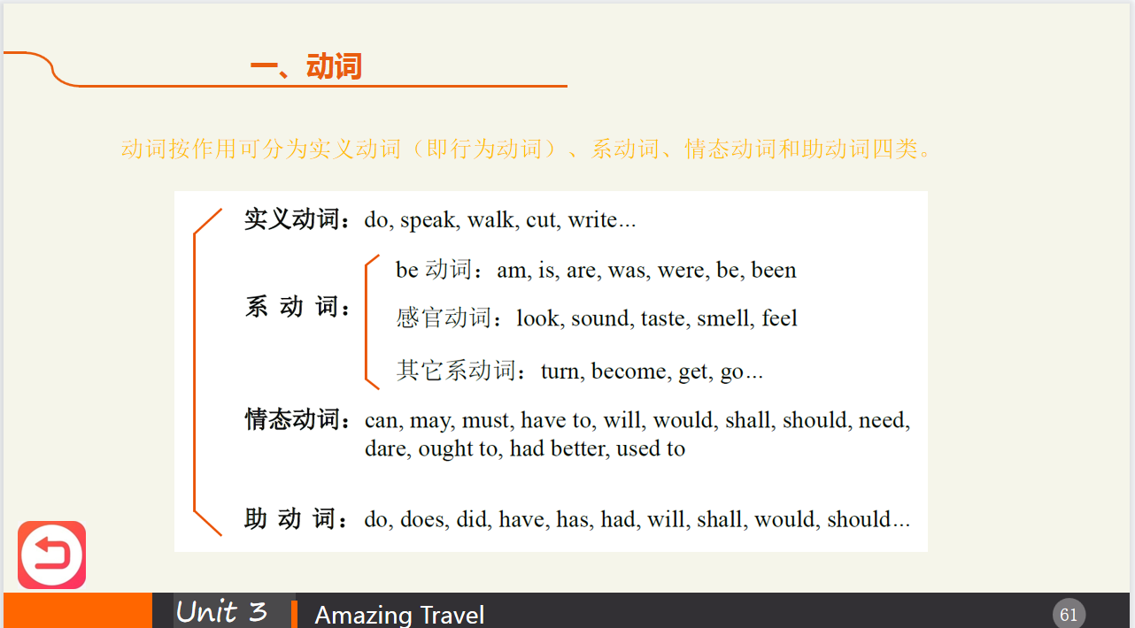
2 Ask students to finish the exercises.
3 Check the answers.
Assignments
- 100% of students grasp what are verbs and articles .
- 80% of students know how to use verbs and articles correctly.

Part Ⅴ Applied Writing

Steps
1 Introduce the details and format of note and in what circumstances it will be used.
Every note is made up of five essential parts, including heading, salutation, body, closing and signature. They comprise the structure or framework of your note. You should follow the general form if you want to produce a correct acceptable note.
Heading | Date
Salutation (use colon or comma) | Dear…,
Body | _____________________________________________
 | ____________________________________________________
Closing | Sincerely,
Signature | Signature
- Explain the main points in Note.
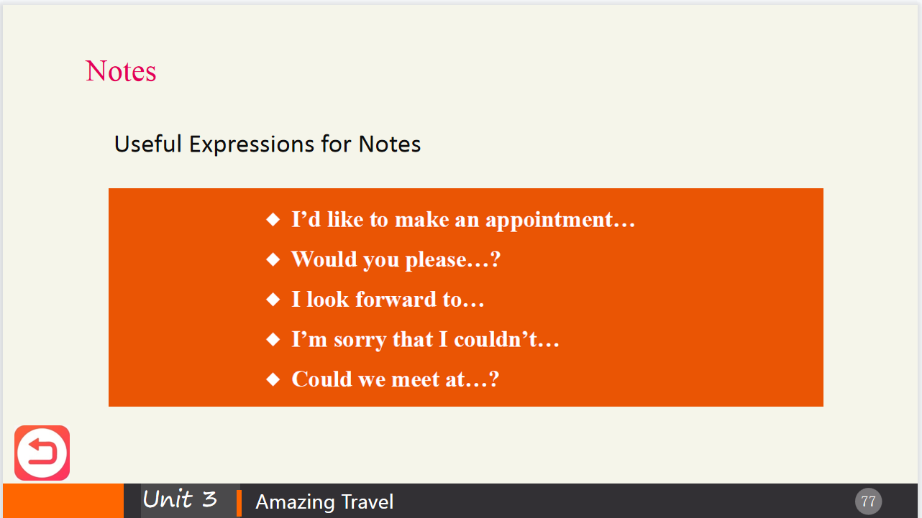
3 Ask students to read the sample and write a note independently required in the textbook independently.
Assignments
- 100% of students can get the main points in note.
- 80% of students can write a note required independently.

Period 4

Part Ⅵ Watching & Performing

Steps
1 Introduce the main plot of the movie.
《飞屋环游记》是皮克斯动画工作室于2009年制作的第十部动画电影，也是其首部3D电影。该电影由华特迪士尼影业发行，曾在纽约Comic-Con展上试映电影的前45分钟，好评如潮。随后影片受邀成为第62届戛纳电影节开幕片，《飞屋环游记》是首部担任戛纳开幕片的3D动画片。本片于2009年5月29日在北美公映。影片讲述的是78岁的卡尔老先生，为了信守对爱妻的承诺，决心带着他与妻子埃莉共同打造的房屋一飞冲天的动人故事。本片入围奥斯卡最佳影片、最佳动画片等奖项，成为继《美女与野兽》之后的第二部入围最佳影片的动画片。
2 Play the movie clip.
3 Ask the students to imitate the movie clip.
4 Explain the useful expressions for receptionists and customers when booking a ticket.
5 ASK the students to make their own dialogue and perform it in groups.
6 Ask the students to appreciate the lines from: A Dog’s Purpose.

