Unit 6 Know Yourself
“知人者智，自知者明”.人是多么复杂的一个独立综合体。要认识自己，必须拥有一份让自己变得更勇敢、更睿智的决定，再依靠一些方法步骤。
当然，在不同的人生阶段，人会发展出不同的状态和感悟，也会成就不同的自己，也因为人会不停学习、不停成长、不停变化，这些自己的评价连同外界的评价，都会不断变化不断丰富，自我认知也就是贯穿一辈子的事。
想想，未来那个你，比今天这个你要更出色更优秀，这样的自我成长和成就，就足以让人兴奋了不是么？所以可以确定的是，认识自己一定是成就自己的最优解。

Unit Objectives

- Knowledge and skill:
Students should be able to talk about the ways to know yourself and others.
Students should grasp the new words and expressions.
Students should grasp the grammar about present perfect tense.
Students should master how to write application letters.
- Feeling, attitudes, and values:
Students should be able to find ways to record life and share them with classmates.
- Ideological and Political Aims（思政目标）
Students should know why do they need “know yourself”.
Students should know how to “know yourself”.

Teaching Important Points

1 Master the following words and phrases:
passionate, superior, worthless, prove, proof, diagnose, make an effort to, worthy, instill, set in stone, available, publish, pick sb. apart, determine
2 Enable the students to get to know the ways to know themselves.
3 Ask the students to grasp the phrase of receiving a client during a business exposition.
4 Grasp the grammar of present perfect tense.

Teaching Difficult Points

1 Improve the students’ reading ability.
2 Ask the students to grasp how to write application letter.

Teaching Aids

A multimedia classroom
The blackboard

Teaching Approach

Tasked-based; Group work

Teaching Procedures

Period 1

Part Ⅰ Lead-in

Exercise Ⅰ(steps) | Exercise Ⅱ(steps) | Exercise Ⅲ (steps)
1 Play the video twice and explain new words.  2 Ask the students to discuss on their handwriting and invite some of them to share their views.  personality/ˌpɜːsə'næləti/ n. 性格；个性；人格  prediction /prɪ'dɪkʃn/ n. 预测；预报；预言  accurate /'ækjərət/ adj. 精确的；准确的 | 1 Play the video again and ask students to discuss on their own handwriting and personality.  2 Ask the students to finish the exercise and invite several students to share their views. | 1 Explain the useful expressions in the table.  2 Invite the students to interview each other for more methods of knowing themselves.

Exercise Ⅰ

Words and Phrases
* small handwriting (字写得很小) | shy (害羞的), studious (勤奋的), concentrated (专注的), meticulous (细心谨慎的)
* large handwriting (字写得很大) | outgoing (外向的), love attention (有爱心的), people-oriented (乐于与人相处的)
* average handwriting (字写得大小适中) | well-adjusted (适应性强的), adaptable (有适应能力的)
* round letters (字写得很圆) | artistic (有艺术天赋的), creative (有创造力的)
* pointed letters (字写得中规中矩) | aggressive (有进取心的), intense (认真的), intelligent (聪明的), curious (有好奇心的)
* connected letters (字连在一起) | logical (逻辑性强的), systematic (有条不紊的)
* crossing the very top of “t” (字母t的小横线写在最上面) | good self-esteem (自尊心强的), optimistic (乐观的), ambitious (有野心的)
* crossing the middle of “t” (字母t的小横线写在中间) | confident (自信的), comfortable in your own skin (态度释然的；自我认知清晰的)
* open “o” (字母o开口写) | talkative (健谈的), social (合群的), expressive (表达欲强的)
* closed “o” (字母o闭口写) | private (不爱吐露心思的) ; introvert (内向的)
* dot lands high over the “i” (字母i的点写得很高) | imaginative (想象力丰富的)
* dot lands to the left of the “i” (字母i的点写在上边偏左) | procrastinator (爱拖延的人)
* dot is perfectly over the “i” (字母i的点写在正上方) | detail-oriented (注重细节的), organized (有条理的), emphatic (果断的)
* putting a circle over “i” (字母i的点写成了小圆圈) | visionary (爱幻想的), childlike (童真的)

思政拓展：苏格拉底 “know yourself / 认识你自己”
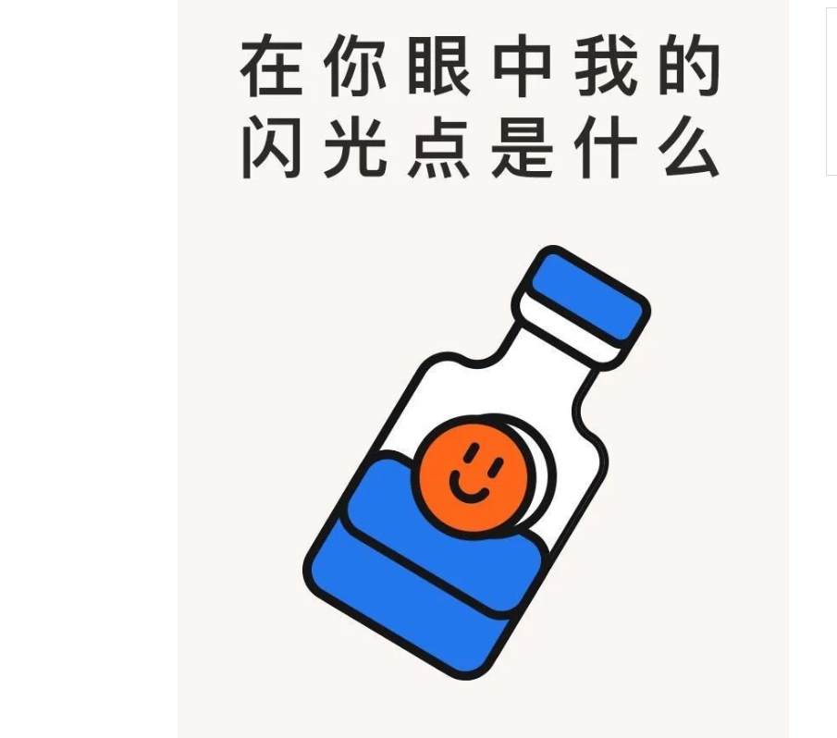
认识你自己就是告诫大家要学会自知，了解自己是谁，用我们现代的话来说就是人一定要有自知之明，亦告诫人们要时时反省自己，切勿过度，切勿忘乎所以。识人难，认识自己更难，因为虚荣、贪欲、自私心是一个狡猾的魔鬼，常常迷惑人的头脑，使人失去理智。真正客观地认识自己也并不是一件容易的事，需要躬身反省的功夫。只有真正认识了自己，才能更深刻地认识别人，才能根据自己和别人的情况处理好与他人的关系。
https://mp.weixin.qq.com/s?src=11&timestamp=1636378098&ver=3424&signature=3oJKpTqBSiRNvSWjzEe9ODx7Ulrz5HySTo-hA5K9duvl2mqLwi9L5hwfQm0OplJKvQRSeBqlZhQlSeO0YHFN0xO*v0WEwpUtoVKqNIKrDzkhN-EjAhKdDC5DP4PI*A0x&new=1

Part Ⅱ Listening and Speaking

Exercise I

Steps
1 Explain new words and expressions in the table.
2 Play the dialogues twice and then ask the students to fill in the blanks.
3 Check the answers.

Words and Phrases
1 strength /streŋθ/ n. 优点；优势；长处
e.g. The ability to keep calm is one of her many strengths.
能够保持冷静是她的一个优点。
strength and weakness 优缺点
2 prove /pruːv/ v. 证明；证实
e.g. Just give me a chance and I will prove it to you.
只要给我个机会，我会证明给你看。
She was determined to prove everyone wrong. 她决定证明大家都错了。
3 admire /əd'maɪə(r)/ v. 钦佩；仰慕；赞赏
e.g. I really admire your passion. 我确实钦佩你的热情。
The school is widely admired for its excellent teaching.
这所学校教学优秀，远近称誉。

Exercise Ⅱ

Steps
1 Explain the useful expressions about one’s personality.
* What kind of person do you think you are?  * 你认为，你是哪种类型的人？ | * I think I’m… in daily life.  * 我认为，在日常生活中，我是……
* When I’m at work, I’m…  * 在工作中，我是…… | * Do you think you have learnt enough at school?  * 你觉得你在学校学的东西足够了吗？
* As a student, I know there are lots of things to learn, so I’m always willing to…  * 作为一名学生，我知道还有许多东西要学，所以我总是很乐意…… | * As an intern, there are more knowledge and practical skills to learn, so I think I will be…  * 作为实习生，还有更多知识和实用技能需要学习，所以我觉得，我将会……
* How would you like to evaluate yourself at school?  * 你怎样评价你在学校的表现？ | * I know how to get along with…  * 我知道如何与……相处。
* What qualities do you think you have are suitable for this position?  * 你认为，你有哪些适合这个岗位的特质呢？ | * I think I’m qualified for this position because…  * 我认为，我能胜任这个岗位，是因为……
2 Encourage the students to make dialogues in the given situation.
3 Give the students more samples and make a short summary.

Words and Phrases
1 evaluate /ɪ'væljueɪt/ v. 评价；评估
e.g. Don’t evaluate a person on the basis of appearance. 不要以相貌取人。
The market situation is difficult to evaluate. 市场状况难以评估。
2 get along with 与……相处
e.g. My classmates and I get along well with each other. 我与同事们相处很融洽。
3 qualified /'kwɒlɪfaɪd/ adj. 有资格的；胜任的
e.g. This student is ideally qualified for the job. 这名学生最适合做这项工作。
She’s extremely well qualified for the job. 她完全符合担任这项工作的条件。

Exercise Ⅲ

Steps
1 Introduce the song simply and let the students enjoy it.
《全新的我》（Brand New Me）由美国歌手艾丽西亚·凯斯演唱。这首歌拥有动人的旋律和写实的歌词，描述了一个女孩的变化和心境。准备好发现内心的自我了吗？
2 Ask the students to fill in the blanks.
3 Check the answers.
Assignments
- 100% of students know how to expressions about one’s personality to others (录音或视频).
- 70% of students be able to describe the personalities about themselves(录音或视频).

Period 2

Part Ⅲ Reading

Teaching Focus
 | Text A Intensive Reading | Text B Extensive Reading
Theme | Getting to Know Yourself | The Story of My Life
Words and phrases | passionate, superior, worthless, prove, proof, diagnose, make an effort to, worthy, instill, set in stone, available | publish, pick sb. apart, determine

Text A Intensive Reading

Steps
1 Lead the students to the topic and text.
2 Ask the students to read the text and analyze its structure.
3 Explain the details and language points of the text.
4 Ask the students to finish the exercises.

Pre-Reading Discussions
Text A tells the author’s experience of knowing himself / herself and his / her changes. To lead students into the topic, the teacher is advised to draw the students’ attention to the following pre-reading questions:
Do you think you know yourself well?
What would you do if you found someone superior to you?
By doing this, the teacher may help the students see the structure of the text (for this see the next section “Text Structure”).

Text Structure
The text structurally goes like this: the author thinks that even people are shaped into what they are today, they do not know themselves better. So the author tells about his / her own experience of knowing himself / herself, and then gives readers some suggestions. Namely,
Parts | Paragraphs | Main Ideas
Part One | Paras. 1-2 | While people are shaped into what they are today, they do not know themselves better.
Part Two | Paras. 3-7 | The author tells about his / her own experience of knowing himself / herself.
Part Three | Paras. 8-11 | The author gives three suggestions to help readers to better know themselves.
拓展：窗口理论-自我认识的四个维度。
一、公开的自我
也就是透明真实的自我，这部分自己很了解，别人也很了解。
比如自己的姓名性别、兴趣爱好、性格脾气、做什么工作等等这些容易被别人了解的内容。
二、盲目的自我
别人看得很清楚，自己却不了解。有点“当局者迷、旁观者清”的感觉。
比如有些成功人士之所以成功，他们自己可能都不太清楚，但有些机构和有些人却能很清楚地归纳出他们的成功秘诀。
三、秘密的自我
秘密的自我是指自己了解但别人不了解的部分。
比如自己身上丑陋的疤痕，说过的谎话，冲动时干过的坏事等等。我们每个人在职场工作，可能都会有你不喜欢的人和不愿意的事，比如顶撞过我们的人，坑害过我们的合同。还有我们自己那些不愿见人的各种隐私，这些都是秘密的自我。
四、未知的自我
未知的自我，是别人和自己都不了解的潜在部分，通过一些契机可以激发出来。
比如自己的潜能、潜质等等。美国有个学者研究说，我们普通人其实只开发了我们自己蕴藏能力的1/10，只利用了我们自己身心资源中很小很小的一部分。科学家们也发现，贮存在人类脑内的能力其实是大得惊人的，我们平常其实只发挥了极小的一部分功能。
https://mp.weixin.qq.com/s?src=11&timestamp=1636378895&ver=3424&signature=CeEQf5EDR12cY3SVorSClzamC8OVRwfhPfVN-dvTdguXAO91Fl72EhX-n3IlanneDVdsjo02gf9uEskg95KPvm1-9RQ6goVnMvDMTRy55gczeGvw9ziaN5xItqqFuPtj&new=1

Detailed Study
1 While our experiences clearly helped shape us into what we are today, this does not mean that we surely know who we really are — what we are passionate about and what we want from life. (Para. 2)
passionate /'pæʃənət/ adj.
having very strong feelings about sth. or a strong belief in sth. 狂热的；热诚的
be passionate about 对……充满热情；热爱……
e.g. He was passionate about all literature. 他热爱所有的文学作品。
Language Point:
while在句中表转折，意思是“尽管……”，what we are today是一个what引导的名词性从句，意思是“我们今天的样子”。后半句中that引导的是一个宾语从句，从句中又包含一个名词性从句who we really are，作know的宾语。破折号后面的句子是两个并列的名词性从句，对前面的句子进行补充说明。
2 Having an older sister who was superior to me in study made me feel worthless. (Para. 3)
superior /suː'pɪəriə(r)/ adj.
better than sb. / sth. else; greater than sb. / sth. else 更好的；占优势；更胜一筹
~ to sb. / sth.
e.g. This model is technically superior to its competitors.
这一款式在技术上超过了与之竞争的产品。
worthless /'wɜːθləs/ adj.
(a) (of a person ) having no good qualities or useful skills 品质坏的；不中用的
e.g. Constant rejections made him feel worthless.
不断地遭到拒绝使他觉得一无是处。
(b) having no practical or financial value 没用的；无价值的
e.g. Critics say his paintings are worthless. 批评家说他的画毫无价值。
3 I had proven to everyone else that I was intelligent, but this “proof” seemed strangely hollow. (Para. 4)
prove /pruːv/ v.
to use facts, evidence, etc. to show that sth. is true 证明；证实
~ sth. (to sb.) 向某人证明某事
e.g. Just give me a chance and I’ll prove it to you.
只要给我个机会，我会证明给你看。
proof /pruːf/ n.
information, documents, etc. that show that sth. is true 证据；证明（prove的名词形式）
e.g. These results are a further proof of his outstanding ability.
这些成果进一步证明了他的杰出才干。
proof of purchase 购物证明
4 On leaving university, I was diagnosed with anxiety and depression. (Para. 5)
diagnose /'daɪəgnəʊz/ v.
to say exactly what an illness or the cause of a problem is 诊断（疾病）；判断（问题的原因）
be diagnosed as / with 被诊断为……
e.g. The illness was diagnosed as cancer. 此病被诊断为癌症。
He has recently been diagnosed with cancer. 他最近被诊断出患有癌症。
5 Being so sensitive, I know I am often inﬂuenced by other people’s goals and desires, so I consciously make an effort to find out what I really want by taking the time to listen to myself. (Para. 7)
make an effort to 努力做……
e.g. You should make an effort to learn something new every day.
我们必须努力去每天学一点新东西。
Everybody should make an effort to reduce pollution.
每个人都应为减少污染尽一份力。
Language Point:
此句开头的Being so sensitive是现在分词短语作状语，so后面引导的是表结果的从句，what I really want... myself是名词性从句，作find out的宾语。by后面的现在分词短语作宾语成分。
6 The truth is that everyone is worthy of love, respect, and kindness. (Para. 9)
worthy /'wɜːði/ adj.
(formal) having the qualities that deserve sb. / sth. 值得（或应得）……的
be worthy of 值得……
e.g. A number of the report’s findings are worthy of note.
这份报告里有些调查结果值得注意。
He felt he was not worthy of her. 他觉得他配不上她。
7 It was hard to let go of the ideal image of what university and my life were going to be like, which had been instilled in my head for years. (Para. 10)
instill /ɪn'stɪl/ v.
teach and impress by frequent repetitions （使）获得；逐步灌输
e.g. We must instill a sense of duty in our children.
我们必须培养孩子们的责任感。
I consider it important to instill a pride in the players.
我认为让运动员逐步感到自豪是很重要的。
Language Point:
It was hard to do...表示“做……困难”，此结构中It是形式主语，后面的不定式短语是真正的主语。let go of 的意思是“放开，释放”，what university... like是名词性从句，作of的宾语。which引导的是一个非限制性定语从句，是对前面的ideal image的补充说明。
8 Remember that your life is not set in stone.
set in stone 一成不变
e.g. This doesn’t mean that your goals are set in stone.
这并不意味着你的那些目标就是一成不变的。
9 If we spent much time regretting the missed ones, we would have less time to enjoy the opportunities available right now! (Para. 11)
available /ə'veɪləbl/ adj.
(a) (of things) that you can get, buy or find 可获得的；可购得的；可找到的
e.g. available resources / facilities 可利用的资源（或设备）
When will the information be made available? 何时才可以了解到情况？
(b) (of a person) free to see or talk to people 有空的
e.g. Will she be available this afternoon? 今天下午她有空吗？
The director was not available for comment. 主管没有时间发表意见。
Text B Extensive Reading
Steps
1 Lead the students to read the new words and phrases in Text B and explain their meanings.
2 Ask the students to read the questions in Reading Comprehension and then give them 15 minutes to read the text.
3 Ask the students to finish the exercises in Reading Comprehension.
4 Check the answers.

How to Use the Reading Skills
怎样培养良好的阅读习惯： 培养每天阅读的习惯。每天阅读，关键在于坚持，使学生的阅读习惯自觉养成； 培养集中精力、专心致志的阅读习惯。教师要引导学生学会排除干扰，集中精力，专心致志地读书，养成静心读书的习惯； 培养边读边想边动手的阅读习惯。阅读时边思考边动笔，可以抓住重点，深入理解，培养学生圈点勾画和作批注的习惯。

Detailed Study
1 The night before it was published, I checked my email and saw a message from the managing editor at the time. (Para. 4)
publish /'pʌblɪʃ/ v. to print a letter, an article, etc. in a newspaper or magazine 发表，刊登，登载
e.g. He will publish a statement. 他将公布一项声明。
My object was to publish a scholarly work. 我的目标是出版一本学术著作。
2 I have laid myself out in the pages of this paper word by word, line by line, and allowed my peers to pick me apart. (Para. 5)
pick sb. apart
to find fault with; to express criticism of （非正式用语）对……吹毛求疵
e.g. Let me pick apart a few of the points you make. 我就几点给予批评建议。
At the meeting everybody picked apart Peter because he had beaten a little boy.
在会上，大家都严厉地批评彼得，因为他打了一个小男孩。
3 During this period, I changed from the girl afraid of her own voice to the girl determined to amplify the voices of everyone around her. (Para. 7)
determine /dɪ'tɜːmɪn/ n. to decide definitely to do sth. 决定，决心（做某事）
e.g. They determined to start early. 他们决定早点出发。
She is determined to hold on to her fortune. 她决心要守住自己的财产。
Language Point:
本句中的determined to amplify…作为the girl的后置定语，是分词做定语的情况，意义与定语从句相同，可与定语从句结构互换。the girl determined to amplify相当于the girl who is determined to amplify。

Assignments:
1. Know the skills and improve reading ability（思维导图）

Period 3

Part Ⅳ Grammar

Steps
- Explain the definition and usage of the present perfect tense.
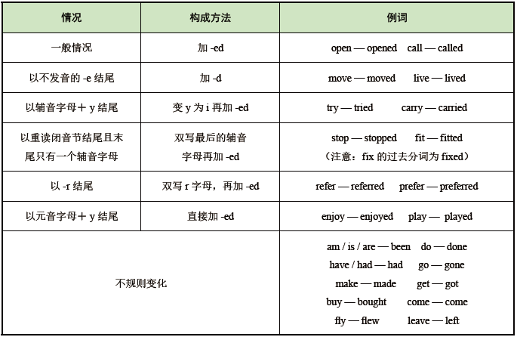
2 Ask the students to finish the exercises.
3 Check the answers.
Assignments
- 100% of students grasp what is the present perfect tense.
- 80% of students know how to use the present perfect tense correctly.
- 60% of students can distinguish the present perfect tense from the past perfect tense correctly.

Part Ⅴ Applied Writing

Steps
1 Explain the method of writing application letters in accordance with the sample.
求职信是求职者写给用人单位的信，目的是让对方了解自己、相信自己、录用自己。它是一种私人对公并有求于公的正式信函。求职信的格式有一定的要求，内容要求简练、明确，切忌模糊、笼统、面面俱到。
求职信需要包含以下内容：标题、称谓、正文及署名。
求职信写作技巧：
- 首先要说明从何种渠道获得此招聘信息，写明自己所要申请的职位及求职的原因；并介绍求职者的有关情况。对所谋求的职务，态度要明朗；介绍有关情况时要简明扼要。
- 写明对所谋求的职务的看法，并对自己的能力做出客观公正的评价，这是求职的关键。
- 最后提出自己希望得到面试的机会，语气要诚恳。
- 写作过程中要注意用词简洁准确，自信且有礼貌，所提供的信息要可信。
- Explain the useful expressions in writing.
✧ In response to your advertisement on the website of…✧ I’m interested in…
✧ My experience in this line of work includes…
✧ I will put my potential into full play and add more profits to the company.
✧ I would appreciate the privilege of an interview.
✧ I am applying for a position of…

3 Ask the students to finish the exercise and make comments.

Period 4

Part Ⅵ Watching & Performing

Steps
1 Introduce the movie and then play the clip.
《BJ单身日记1》是一部根据同名小说改编的英国浪漫喜剧电影。有些人甚至认为它是一部现代版的《傲慢与偏见》，但最重要的是它跟许多现代单身女性产生了前所未有的共鸣。Bridget Jones是一名平凡的女性，不断遭受着年龄、体重、工作、单身及很多不完美之处的打击。新年伊始，Bridget深刻认识到自己需要改变。于是她开始将每天的真实情感都记录在日记中。通过记日记，Bridget逐步认识自己，找回了自信，并且减肥成功，在爱情和事业上获得了巨大收获。这部电影告诉我们，认识自己可以从认识自己的缺点开始，改正缺点，这样你就可以成为更完美、更自信的自己。
2 Ask the students to imitate the movie clip.
3 Ask the students to make their own dialogues in given situations and invite others to score for them.

