Unit 5 Game Isn’t Nothing
任何事物都有它的两面性，网络游戏也有，通过分析网络游戏的利弊，我们可以得知适当游戏益智，过度游戏伤身。
对于网络游戏，既不能视之如洪水猛兽，也不能认为它就是潘多拉的盒子。大学生必须更好地树立正确的“三观”，正确的使用网络游戏，理解网络游戏对大学生的重要意义，运用网络扩大知识视野，树立正确的网络道德观念，从而更好地服务社会造福人类，也使自己在当今竞争洪流中立于不败之地。

Unit Objectives

- Knowledge and skill:
Students can grasp games and attitudes towards games.
Students should grasp the new words and expressions.
Students should grasp the grammar about future tense.
Students should master how to write complaint letters.
- Feeling, attitudes, and values:
Students should be able to change the stereotype about playing games.
- Ideological and Political Aims（思政目标）
Students should know they should treat game reasonably.
Enable students to change the stereotype about playing games

Teaching Difficult Points

1 Master the following words and phrases:
hear of, acceptable, refer to, facilitate, wonder, introduce, competitive, branch out, educate, deserve, access, constant, zero-sum, hold back, suffer, predict
2 Enable the students to treat game reasonably.
3 Ask the students to know how to hold meetings in English
4 Grasp the grammar of future tense.

Teaching Difficult Points

1 Improve the students’ reading ability.
2 Ask the students to grasp how to write complaint letters.

Teaching Aids

A multimedia classroom
The blackboard

Teaching Approach

Tasked-based; Group work

Teaching Procedures

Period 1

Part Ⅰ Lead-in
Exercise Ⅰ(steps) | Exercise Ⅱ(steps) | Exercise Ⅲ (steps)
1 Explain new words in the exercise I.  2 Ask the students to discuss on games and invite some of them to share their views.  attractive /ə'træktɪv/ adj. 有魅力的；迷人的  awesome /'ɔːsəm/ adj. 极好的；很好玩的 | 1 Ask the students to discuss the questions in group.  2 Invite one or two groups to share their views. | 1 Play the video twice and ask the students to discuss on games and life.  2 Invite one or two groups to share their views.

Exercise Ⅰ
A clear objective makes games more attractive. | 明确的目标使游戏更吸引人。
The scenes in the game are awesome. | 游戏场景十分酷炫。
The feeling of fighting with my teammates is exciting. | 与队员一起战斗的感觉非常棒。
I choose to play, instead of being pushed to. | 我拥有主动权，而不是被迫去玩。

思政拓展：玩物丧志的英文翻译
Ask the students to translate idioms“玩物丧志”into English.
了解玩物丧志的故事背景及中文含义，试着将该成语翻译成英文。
出自《书·旅獒》：“玩人丧德，玩物丧志。” 孔 传：“以器物为戏弄则丧其志。” 宋 朱熹 《近思录》卷二：“ 明 道先生 以记诵博识为玩物丧志。”典故是：
春秋时，卫懿(yì)公是卫国的第十八代君主。卫懿公特别喜欢鹤，整天与鹤为伴，如痴如迷，丧失了进取之志，常常不理朝政、不问民情。他还让鹤乘高级豪华的车子，比国家大臣所乘的还要高级，为了养鹤，每年耗费大量资财，引起大臣不满，百姓怨声载道。

补充阅读：玩物丧志与玩出大成就！
https://mp.weixin.qq.com/s?src=3&timestamp=1636467277&ver=1&signature=KQTXWF9nzYir*g5uD2swX8SdvC2yVG95s40gBlrU0MJptpkmAH5rc*aa*2BkrSF9klhg7iCFan1H2aTwHMjH3ZDMlwNhe8GKwlvGLQe-YmCINrj1pch1-GFI3ThozKfiIaYa-qXpn1qPVWr8mbi-3Dub391KFneybn2KoPUIODQ=
结合下列译文，再次强调“玩物丧志”对人生的影响，并让学生反思。
One will lose ambition while being immersed in interests.
Excessive attention to plaything saps your will.
Be a playboy without ambitions.
sap one's spirit by seeking pleasures.

Assignments
- 100% of students should grasp games and attitudes towards games.
2.60% of students can explain new words in the exercise I.
3.30% of students can make more sentences based on the knowledge they have learned; they can search for more information about games and life with classmates.

Part Ⅱ Listening and Speaking

Exercise I

Steps
1 Explain new words and expressions in the table.
2 Play the dialogues twice and then ask the students to fill in the blanks.
3 Check the answers.

Words and Phrases
1 release /rɪ'liːs/ v. 公开；公布；发布
e.g. Police have released no further details about the accident.
关于这次事故，警方没有透露更多的细节。
to release a movie / book / CD 发行电影（书或激光唱片）
new products released onto the market 投放到市场的新产品
2 addict /ə'dɪkt/ v. 上瘾；（使）沉溺
be addicted to sth.
e.g. What if I’m addicted to the game? 我对这款游戏上瘾了怎么办？
3 ban /bæn/ v. 禁止某人做某事
~ sb. from sth. / from doing sth.
e.g. He was banned from the meeting. 他被取消了出席会议的资格。
He was banned from driving for six months. 他被禁止驾驶六个月。

Exercise Ⅱ

Steps
1 Explain the useful expressions about games introduction.
* What type of game would you like?  * 您喜欢哪一款游戏？ | * I don’t know much about the motion sensing games.  * 我不太了解体感游戏。
* Could you please recommend some types to me?  * 您能给我推荐一些款式吗？ | * Do you want to buy it for yourself or as a present for someone else?  * 您是给自己买还是作为礼物送给别人呢？
* I’d like to buy one for my son as his birthday gift.  * 我想为儿子买一套游戏作为生日礼物。 | * I think this one is perfect for a little boy.  * 我认为这一款非常适合小男孩。
* The scenes in this game are attractive for kids.  * 游戏中的场景对孩子很有吸引力。 | * Motion sensing games involves lots of movements which can help kids exercise more while having fun.  * 体感游戏包含多种动作，在娱乐的同时，还可以帮助孩子锻炼。
* You can try our trial product.  * 您可以体验一下我们的试用产品。 | * It will be the best if your son could come here and experience it by himself.  * 最好让您的儿子亲自过来体验一下。
2 Encourage the students to make dialogues in the given situation.
3 Give the students more samples and make a short summary.

Words and Phrases
1 recommend /ˌrekə'mend/ v. 推荐；举荐；介绍
~ sb. / sth. to sb. for / as sth.
e.g. I recommend the book to all my students. 我向我所有的学生都推荐这本书。
Can you recommend a good hotel? 你能推荐一家好的饭店吗？
2 by oneself 单独；亲自
e.g. One should learn to deal with one’s problems by oneself.
每个人应该学会自己独立解决问题。

Exercise Ⅲ

Steps
1 Introduce the song simply and let the students enjoy it.
《超越游戏》（Beyond the Game）由日本高科技舞曲创始人Alout演唱。歌曲表现了对竞赛和友谊的极大热情。准备好跟着节奏热血沸腾了吗？
2 Ask the students to fill in the blanks.
3 Check the answers.
Assignments
- 100% of students know how to introduce games to others (录音或视频).
- 70% of students be able to make dialogues about games introduction. (录音或视频).

Period 2

Part Ⅲ Reading

Teaching Focus
 | Text A Intensive Reading | Text B Extensive Reading
Theme | Gamers Aren’t Deﬁned by Their Game | Your Life is Tetris
Words and phrases | hear of, acceptable, refer to, facilitate, wonder, introduce, competitive, branch out, educate, deserve | access, constant, zero-sum, hold back, suffer, predict

Text A Intensive Reading

Steps
1 Lead the students to the topic and text.
2 Ask the students to read the text and analyze its structure.
3 Explain the details and language points of the text.
4 Ask the students to finish the exercises.

Pre-Reading Discussions
Text A tells that people have misunderstandings about games and gamers. In fact, playing games means much more than playing and can even prevent gamers from some diseases. To lead students into the topic, the teacher is advised to draw the students’ attention to the following pre-reading questions:
Have you ever played any eSports?
What is your opinion about eSports?
By doing this, the teacher may help the students see the structure of the text (for this see the next section “Text Structure”).

Text Structure
The text structurally goes like this: the author first tells that gamers are misunderstood in the media and gaming is not acceptable. Then the author gives an example of himself to explain the meanings of gaming. In the end, the author calls on readers to understand gamers and gaming. Namely,
Parts | Paras. | Main Ideas
One | Paras. 1―3 | The author dreamed of living in big city from very young, but not long after lived in big city, he / she left the city and move to the countryside.
Two | Paras. 4―14 | The reasons why the author leaves big city and the benefit he / she discovered.
Three | Para. 15 | Big city isn’t necessarily where dreams are made.

Detailed Study
1 How many of you have heard of eSports? (Para. 1)
hear of
to know about sb. / sth. because you have been told about them 听说；知道；得悉
hear of sb. / sth.; hear sth. of sb. / sth.
e.g. I’ve never heard of the place. 我从来没听说过这个地方。
She disappeared and was never heard of again.
她消失了，再也没人听到过她的消息。
2 Gaming is a huge part of my life, but unluckily it is not as acceptable as my other hobbies such as math, tennis and basketball. (Para. 2)
acceptable /ək'septəbl/ adj.
agreed or approved of by most people in a society （社会上）认同的，认可的
e.g. Children must learn socially acceptable behavior.
儿童必须学会社会上认可的行为举止。
Language Point:
gaming是动名词作主语，谓语动词用单数形式。but表示转折，转折从句中not as... as的意思是“不像……一样”。such as意思是“例如”，后面接列举的单词。
3 When people refer to gaming nowadays, they’re talking about electronic gaming. (Para. 3)
refer to
to describe or be connected to sb. / sth. 描述；涉及；与……相关
e.g. This paragraph refers to the events of last year. 这一段说的是去年发生的事。
4 ESports is basically a competition that’s facilitated through an Xbox or a computer. Many people wonder how eSports can be considered as sports. (Para. 4)
facilitate /fəˈsɪlɪteɪt/ v.
(formal) to make an action or a process possible or easier 促进；促使；使便利
e.g. The new trade agreement should facilitate more rapid economic growth.
新贸易协定应当会加快经济发展。
wonder /'wʌndə(r)/ v.
to think about sth. and try to decide what is true, what will happen, what you should do, etc. 想知道；想弄明白；琢磨
~ about sth. 想知道
e.g. We were wondering about next April for the wedding.
我们寻思着下个四月举行婚礼可好。
5 My brother and I played games when we were younger and finally he was the one who introduced me to competitive gaming and eSports. (Para. 5)
introduce /ˌɪntrə'djuːs/ v.
to tell two or more people who have not met before what each other’s names are; to tell sb what your name is 把……介绍（给）；引见；（自我）介绍
~ A (to B) / ~ A and B / ~ yourself (to sb.)
e.g. He introduced me to a Greek girl at the party.
他在聚会上介绍我认识了一位希腊姑娘。
competitive /kəm'petətɪv/ adj.
(a) used to describe a situation in which people or organizations compete against each other 竞争的；竞技的
e.g. competitive games / sports 竞技性的比赛（或体育运动）
Graduates have to fight for jobs in a highly competitive market.
毕业生不得不在竞争激烈的市场上奋力争取找到工作。
(b) as good as or better than others 有竞争力的
e.g. We need to work harder to remain competitive with other companies.
我们必须更加努力工作以保持对其他公司具有竞争力。
Language Point:
when we were younger是when引导的时间状语从句；and连接两个并列句。后面who introduced me to competitive gaming and eSports是定语从句，修饰限定前面的the one。
6 I’ve always done well in school and I’ve been likely to branch out and try to find different ways to educate myself. (Para. 6)
branch out 扩大范围
~ into sth.
to start to do an activity that you have not done before, especially in your work or business 涉足（新工作）；拓展（新业务）
e.g. The company branched out into selling insurance.
该公司开展了保险销售业务。
educate /'edʒukeɪt/ v. to teach them better ways of doing sth. or a better way of living 教育
e.g. The campaign is intended to educate the public to respect the environment.
这一运动旨在教育公众爱护环境。
She was educated in the US. 她是在美国受的教育。
7 Gaming deserves your respect. (Para. 7)
deserve /dɪ'zɜ:v/ v. if sb./ sth. deserves sth., it is right that they should have it, because of the way they have behaved or because of what they are 值得；应得；应受
deserve sth.
be right so that sb. should have it 值得；应得；应受
e.g. You deserve a rest after all that hard work. 辛苦劳累那么久，你该休息一下了。
The report deserves careful consideration. 这报告应该认真考虑。
Text B Extensive Reading

Steps
1 Lead the students to read the new words and phrases in Text B and explain their meanings.
2 Ask the students to read the questions in Reading Comprehension and then give them 15 minutes to read the text.
3 Ask the students to finish the exercises in Reading Comprehension.
4 Check the answers.

How to Use the Reading Skills
结构笔记：把文章的框架结构用简练的语言，用标题的形式依次记载下来。这样既概括了文章的内容，锻炼了概括能力，又使得文章在我们的印象中更具有条理性，逻辑结构更为清晰。比如课本上每一篇阅读的讲解前，引导学生做文章结构分析，把分析结果记录下来就可以是结构笔记。
概念阅读：在阅读理解中，常会出现关于同一主题的不同的小文章罗列在一起，这种情况下适合选用概念笔记法，记录不同文章对该概念的讲解。这样再回头看时，一目了然，便于定位信息，节省时间。

Detailed Study
1 My phone couldn’t access the internet or send a Snapchat, but I found it could kill boredom with its one included game: Tetris. And I became addicted. (Para. 1)
access /'ækses/
(a) v. (formal) to reach, enter or use sth. 到达；进入；使用
e.g. The loft can be accessed by a ladder. 搭梯子可以上阁楼。
(b) n. the opportunity or right to use sth. or to see sb. / sth.（使用或见到的）机会，权利
~ to sth. 获取……
e.g. Students must have access to good resources.
学生必须有机会使用好的资源。
2 It sits on the front page of my apps, a constant reminder that life is Tetris, not chess. (Para. 2)
constant /'kɒnstənt/ adj. happening all the time or repeatedly 连续发生的；不断的；重复的
e.g. This entrance is in constant use. 此入口经常使用。
Babies need constant attention. 婴儿一刻也离不开人。
3 I treated everything like it was zero-sum when there was so much else to gain. And it holds you back. (Para. 3)
zero-sum 零和的
zero-sum game 零和博弈；零和游戏；零和比赛
e.g. It’s a zero sum game. Somebody wins and somebody loses.
这是一场零和博弈。一些人会赢，一些人会输。
hold back 控制；隐藏；阻碍；犹豫不决
e.g. She kept trying to hold back her tears. 她一直在试图抑制住眼泪。
He was able to hold back his anger and avoid a fight.
他忍住了怒气，避免了一场殴斗.
4 There really are no big, bad enemies who exist to make you suffer. (Para. 5)
suffer /'sʌfə(r)/ v. to be badly affected by a disease, pain, sadness, a lack of sth., etc. （因疾病、痛苦、悲伤等）受苦，受难，受折磨
~ from sth. / ~ for sth.
e.g. I hate to see animals suffering. 我不忍心看动物受苦。
Many young people suffer from acne and angst.
许多年轻人都会受到青春痘和焦虑的困扰。
He made a rash decision and now he is suffering for it.
他当初草率决定，现在吃苦头了。
5 You play for the present moment, trying to construct the best possible form of pieces, knowing that it is impossible to predict the situation even two pieces from now.
(Para. 7)
predict /prɪ'dɪkt/ v. to state or make a declaration about in advance 预言；预测
e.g. The latest opinion polls are predicting a very close contest.
最新的民意测验预言，这将是一场势均力敌的竞赛。
Language Point:
be impossible to do sth. 意为“不可能做某事”。It is + adj. + to do sth. 为固定句型，意为“做某事是……的”。其中，it充当形式主语，真正的主语是后面的动词不定式结构。
e.g. It is important to choose enjoyable, nutritious food.
选择既好吃、营养价值又高的食物很重要。

Period 3

Part Ⅳ Grammar

Steps
1 Explain the definition and usage of the future tense. 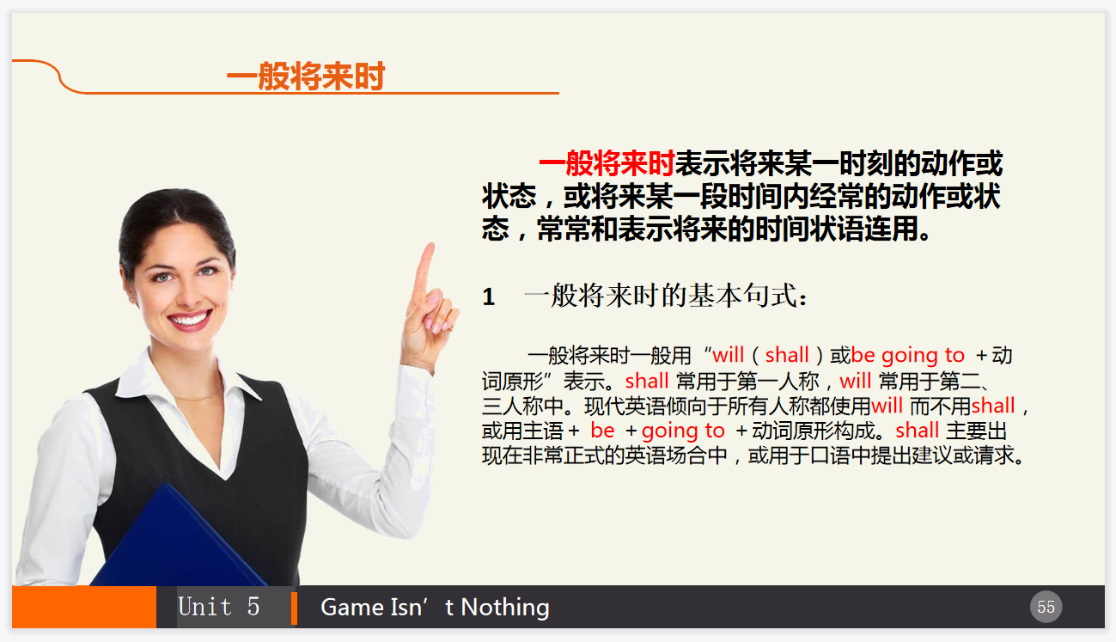
2 Ask the students to finish the exercises.
3 Check the answers.

Part Ⅴ Applied Writing

Steps
1 Explain the method of writing complaint letters in accordance with the sample.
投诉信是消费者在商品交易或接受服务过程中利益受到侵犯时，以书面形式向生产商、服务商或有关组织及部门提出投诉的一种专用书信。
投诉信通常包括以下几个方面的内容：
1 开头：自我介绍，交代投诉内容，表明本信的目的和要求。
2 正文：实事求是地阐述问题发生的经过，切记不要夸大其词；指出问题引起的后果；提出批评及处理的意见或敦促对方采取措施或者提出所希望的赔偿以及补救方式。
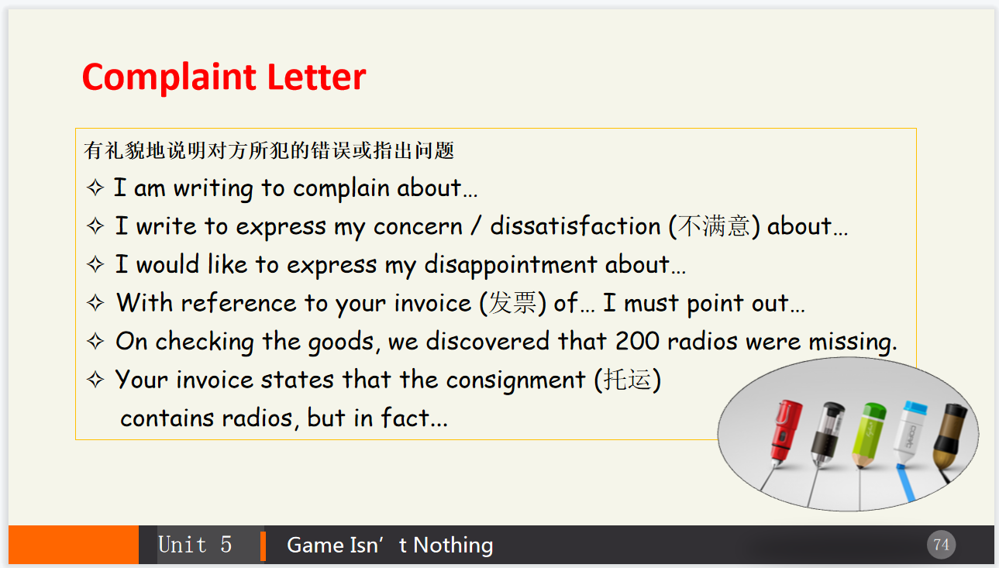

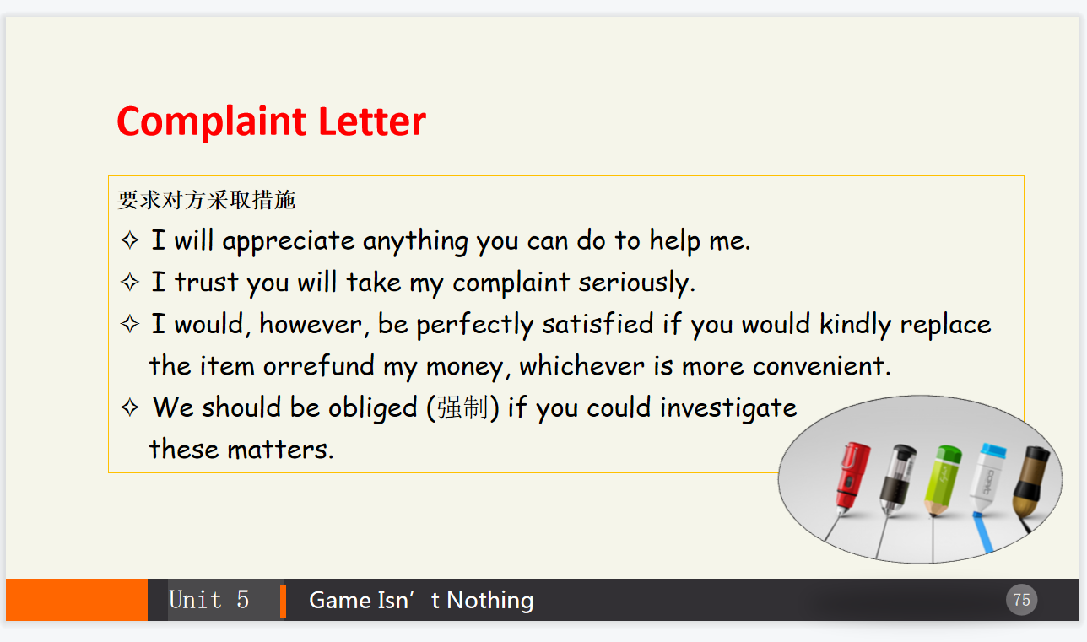3 结尾：表达希望问题得到迅速恰当解决的强烈愿望，希望尽快得到满意的答复。

2 Explain the useful expressions in writing.
3 Ask the students to finish the exercise and make comments.

Period 4

Part Ⅵ Watching & Performing

Steps
1 Introduce the movie and then play the clip.
《超神》是一部由英雄联盟玩家、著名编剧导演Mickey Finnegan 编导的小成本微电影。该电影带给观众强大的视觉冲击和情感共鸣，深受广大职业玩家的欢迎。故事情节主要是通过一个名叫Alex的高中生的故事展开的。Alex一直很喜欢玩电竞游戏，妈妈因病去世之后，他由外婆抚养。外婆对Alex要求十分严格，要求他好好学习，考好大学，找到好工作，每天必须坚持练钢琴。一天，Alex与外婆之间发生了一场激烈的争吵，Alex离家出走来到了网吧。偶然间他获得机会参加了一场职业赛手的友谊赛，并被职业赛手猎手看中。
2 Ask the students to imitate the movie clip.
3 Ask the students to make their own dialogues in given situations and invite others to score for them.

