Unit 3 Money
巴菲特曾言：开始存钱并及早投资，这是最值得养成的好习惯。
随着社会发展，大学生“金钱观”和理财意识需要科学引导。培养一个正确的金钱观是很重要的。对于大学生而言，学会理财的最大意义并不在钱的多少，关键在于学会培养管理金钱的意识，掌控生活的手段，而这恰恰是实现未来理想所需要迈出的第一步。

Unit Objectives

- Knowledge and skill:
Student should be able to talk about money and wealth management.
Students should grasp the grammar about past tense.
Students should master the principle of letters of thanks.
Students should grasp the words and phrases in this unit.
- Feeling, attitudes, and values:
Students should be able to manage their own money in a responsible way.
- Ideological and Political Aims（思政目标）
Students should know how to use the living expenses at cllage .
Students should develop a good sense of money .

Teaching Important Points

1 Master the following words and phrases:
vice versa, achieve, be hungry to, accomplish, fulfill, essence, , cut one’s teeth, be my guest, propose, involve, risky, offer, manage to
2 Enable the students to understand the importance of wealth management, and have a correct view of money.
3 Ask the students to grasp how to talk about new lifestyle.
4 Grasp the grammar of past tense.

Teaching Difficult Points

1 Improve the students’ reading ability.
2 Ask the students to grasp how to write letters of thanks.

Teaching Aids

A multimedia classroom
The blackboard

Teaching Approach

Tasked-based; Group work

Teaching Procedures

Period 1

Part Ⅰ Lead-in

Exercise Ⅰ(steps) | Exercise Ⅱ(steps)
1.Invite the students to discuss the items that they can’t live and lead them to the topic “Money”.  2.Play the video twice and ask the students to share the answers in group.  3 Explain new words and phrases below. | 1 Ask the students to discuss how to make use of money in group.  2 Invite one or two groups to share their views.

Exercise Ⅰ

Words and Phrases
1 allocate /'æləkeɪt/ v. 拨……（给）；划……（归）
e.g. They intend to allocate more places to mature students this year.
今年他们打算给成人学生提供更多的名额。
2 put off 取消；撤销
e.g. It’s too late to put them off now. 现在已来不及取消与他们的安排了。
3 allowance /ə'laʊəns/ n. 零用钱；补贴
e.g. an allowance of $20 a day 每天20元补贴

Exercise Ⅱ

Words and Phrases
1 borrow /'bɒrəʊ/ v. 借；借用
~ sth. from sb. / sth. 向某人借某物
e.g. Members can borrow up to ten books from the library at any one time.
会员在图书馆每次最多可借十本书。
2 afford /ə'fɔːd/ v. 买得起；常与can, could连用，多用于否定句或疑问句
e.g. Can we afford a new car? 我们买得起一辆新车吗？
We can’t afford to go abroad this summer. 今年夏天我们没有足够的钱出国。
3 manage /'mænɪdʒ/ v. 管理
e.g. We need people who are good at managing. 我们需要擅长管理的人。
思政拓展：苏东坡的金钱观
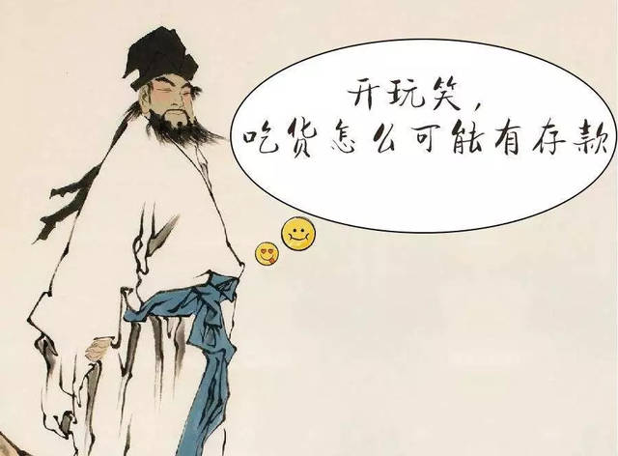
一个人如何对待义与利、荣与辱、苦与乐、得与失，是否公道、正派、诚实、善良、豁达、洒脱、友爱、敦厚，从他对待金钱的态度上均能一目了然。一个人若不计较金钱，就不会成日价营营苟苟、患得患失，更不会贪污腐化、违法乱纪。苏东坡对金钱的超脱，决定了他对人生的超脱。
[转载]苏东坡的金钱观_13思政杨倩_新浪博客
http://blog.sina.com.cn/s/blog_13e993b110102vtvg.html

Part Ⅱ Listening and Speaking

Exercise I

Steps
1 Explain new words and expressions in the table.
2 Play the dialogues twice and then ask the students to fill in the blanks.
3 Check the answers.

Words and Phrases
1 sacrifice /'sækrɪfaɪs/ v. 牺牲；奉献
~ sth. (for sb. / sth.)
e.g. She sacrificed everything for her children. 她为子女牺牲了一切。
2 name after 以……命名
e.g. The planet was named after a scientist.
这颗行星是以一位科学家的名字命名的。
3 invest /ɪn'vest/ v. 投资
e.g. He invested his life savings in his daughter's business.
他把一生的积蓄投资到了女儿的企业。
4 depend /dɪ'pend/ v. 取决于……；视……而定
depend on 取决于；依靠
e.g. Remember, happiness doesn’t depend upon who you are or what you have; it depends solely upon what you think.
请记住，幸福不在于你是谁或者你拥有什么，而仅仅取决于你的心态。
It depends. 视情况而定。（可单独使用）

Exercise Ⅱ

Steps
1 Explain the useful expressions about scholarship.
* Do you think 8,000 yuan is a lot of money for a student?  * 你认为8,000元对于学生而言是一大笔钱吗？ | * What are you planning to do when you get the money?  * 你准备如何处置这笔钱？
* I’m not a person with a clear financial concept.  * 我不是一个很有理财头脑的人。 | * I will save some for…, and the rest will be spent on…  * 我会攒一部分，用于……，剩余的可能会用来……
* I’m going to buy… for…  * 我想给……买…… | * Maybe you can save it for the future.  * 或许你可以为将来存点钱。
* Do you think investing money in the stock market is a good idea?  * 你认为炒股怎么样？ | * Paying for my student loan is the first thing I need to do.  * 还清助学贷款是第一要务。
* Have you ever considered spending some money on…?  * 你是否想过用这些钱去…… | * I want to buy myself a…  * 我想给自己买……
2 Encourage the students to make dialogues in the given situation.
3 Give the students more samples and make a short summary.
Assignments
- 100% of students know the useful expressions about scholarship. (录音或视频).
- 70% of students be able to make dialogues and say something about how to use money.(录音或视频).

Exercise Ⅲ

Steps
1 Introduce the song simply and let the students enjoy it.
《身价牌》（Price Tag）由美国独立歌手泰勒·沃德演唱。歌曲鼓励听众要享受生活，而不是只关注金钱。金钱是否曾经阻碍了你的幸福呢？
2 Ask the students to fill in the blanks.
3 Check the answers.

Period 2

Part Ⅲ Reading

Teaching Focus
 | Text A Intensive Reading | Text B Extensive Reading
Theme | Money Can’t Buy You Success | A Story About Coins
Words and phrases | vice versa, achieve, be hungry to, accomplish, fulfill, essence, , cut one’s teeth, be my guest | propose, involve, risky, offer, manage to

Text A Intensive Reading

Steps
1 Lead the students to the topic and text.
2 Ask the students to read the text and analyze its structure.
3 Explain the details and language points of the text.
4 Ask the students to finish the exercises.

Pre-Reading Discussions
Text A tells what success is and the relationship between success and money. In the text, the author also gives examples to tell readers the logic of the real world. To lead students into the topic, the teacher is advised to draw the students’ attention to the following pre-reading questions:
Do you think money can bring success or vice versa?
What’s your own view on money?
By doing this, the teacher may help the students see the structure of the text (for this see the next section “Text Structure”).

Text Structure
The text structurally goes like this: the author asks readers to think about the word “success” and then discusses his or her view on money and success. In the end, the author suggests that people should enjoy what they are doing and naturally they would make all the money needed. Namely,
Parts | Paragraphs | Main Ideas
Part One | Paras. 1-4 | An experiment carried by the author.
Part Two | Paras. 5-9 | The author’s views upon money and success.
Part Three | Paras. 10-14 | Examples of rich people to show that success leads to money.

Detailed Study
1 Do you think money can bring success or vice versa? (Pre-reading question 1)
vice versa adv.
used to say that the opposite of what you have just said is also true 反过来也一样；反之亦然
e.g. You can cruise from Cairo to Aswan or vice versa (= also from Aswan to Cairo).
你可以乘船从开罗游览到阿斯旺，也可以从阿斯旺游览到开罗。
2 That’s probably because I’m a lot older than you and happy with what I’ve achieved in life. (Para. 5)
achieve /ə'tʃiːv/ v.
to succeed in reaching a particular goal, status or standard, especially by making an effort for a long time （凭长期努力）达到（某目标、地位、标准）；实现
e.g. There are many who will work hard to achieve these goals.
这里的许多人都将会为实现这些目标而努力。
Language Point:
because后面有两个并列的句子，and后面省略了I am。what引导的名词性从句作介词with的宾语。a lot older相当于much older，意思是“年长得多”。

思政拓展：英语励志视频：金钱与你的关系？幸福人生成功的三要素你都有了吗
https://haokan.baidu.com/v?pd=wisenatural&vid=10262476510736317082
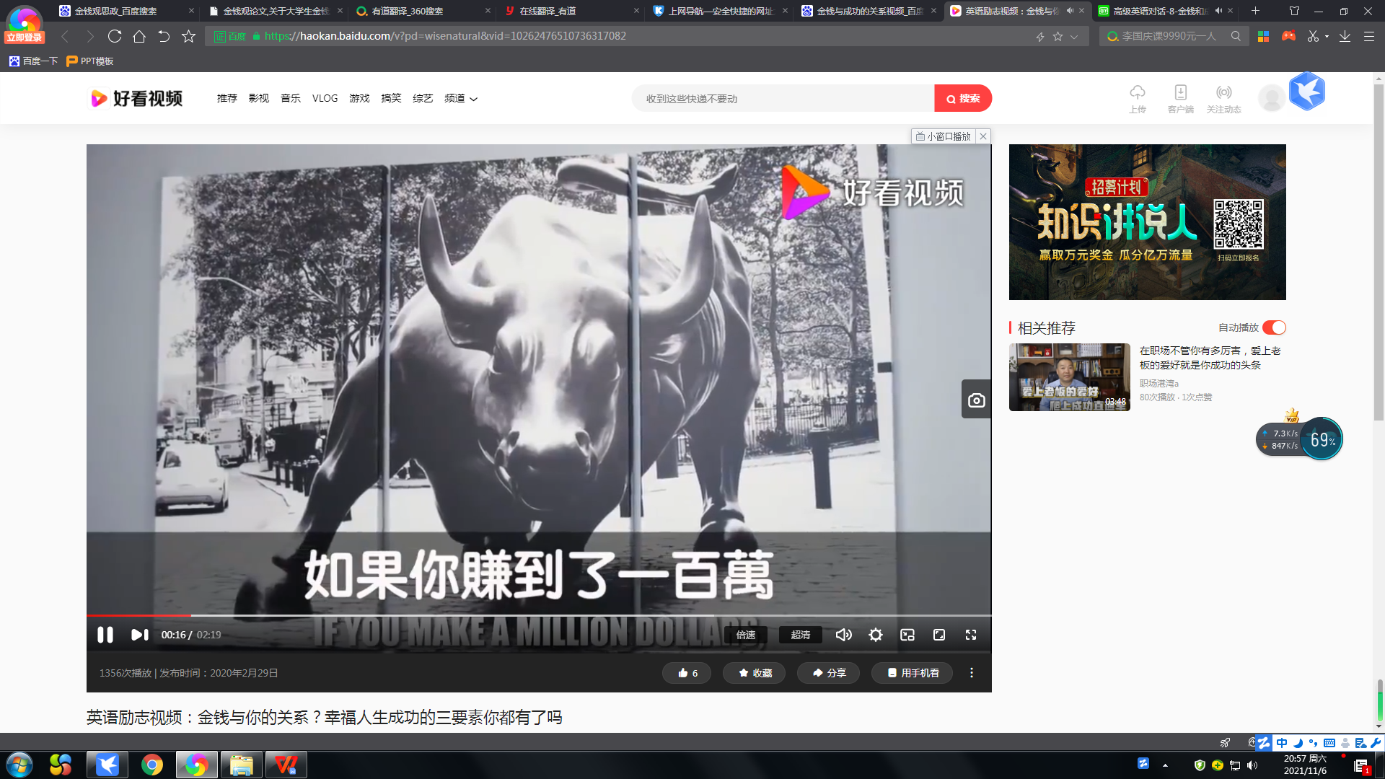

3 However, I’m still hungry to accomplish certain things, as that’s what life is all about. (Para.6)
be hungry to 渴望
e.g. I left Oxford in 1961 hungry to be a critic.
我于1961年离开牛津，渴望成为一名评论家。
be hungry for 渴望
e.g. In today's world many people appear to be hungry for money.
当今世界,有不少人对金钱流露出极度的渴望.
accomplish /ə'kʌmplɪ / v.
to succeed in doing or completing sth. 完成
e.g. The first part of the plan has been safely accomplished.
计划的第一部分已顺利完成。
Language Point:
这里，as引导原因状语从句，意为“因为，由于”。
4 …, I’m certain that I would not be fulfilled. (Para. 6)
fulfill /fʊl'fɪl/ v.
(a) (~ sb. / yourself) to make sb. feel happy and satisfied with what they are doing or have done 使高兴；使满意
e.g. He was able to fulfill himself through his painting.
他通过绘画充分发挥了自己的才能。
(b) to do or achieve what was hoped for or expected 完成；实现；履行
e.g. to fulfill your dream / ambition / potential 实现梦想 / 抱负；发挥潜力
(c) to do or have what is required or necessary 履行；执行
e.g. to fulfill a duty / an obligation / a promise 履行职责 / 义务 / 诺言
Language Point：比较realize, achieve, accomplish 和fulfill
realize v. When someone realizes a design or an idea, they make or organize something based on that design or idea. 强调的是成为现实
accomplish v. put in effect; to gain with effort 强调的是努力之后实现，关键在努力
fulfill v. put in effect 强调的是实现的结果
achieve v. to gain with effort 同样强调是通过努力实现
总结如下：fulfill强调的是实现梦想这个结果，而achieve，accomplish都是强调的是过程。realize做“实现”讲时，可能是某个想法真的实现了，而不一定是梦想。
5 This is the essence of one of life’s great ironies: Success leads to money. (Para. 7)
essence /'esns/ n.
~ (of sth.) the most important quality or feature of sth., that makes it what it is 本质；实质；精髓
e.g. His paintings capture the essence of France. 他的画描绘出法国的神韵。
in essence 从本质上讲；事实上
e.g. In essence, your situation isn’t so different from mine.
从本质上讲，你我的情况并非相差很远。
6 Most of them cut their teeth as engineers, researchers, analysts, or marketers. (Para. 11)
cut one’s teeth (on sth.)
to learn or use at an early age; to do sth. that gives you your first experience of a particular type of work 初次涉足；从中获得经验
Language Point:
这里的as作为介词，意为“作为；身为”，例如as a student，意为“作为一个学生”。
7 If, on the other hand, you want to follow the examples of millionaires or billionaires who really just want to talk about themselves, be my guest. (Para. 14)
be my guest
do as you like （非正式用语）请自便
e.g. If anybody wants to work on this, be my guest. 如果哪位想干这个，请便

Text B Extensive Reading
Steps
1 Lead the students to read the new words and phrases in Text B and explain their meanings.
2 Ask the students to read the questions in Reading Comprehension and then give them 15 minutes to read the text.
3 Ask the students to finish the exercises in Reading Comprehension.
4 Check the answers.

How to Use the Reading Skills
泛读是整体理解文章主题的一种阅读技巧，是一种迅速、广泛地接受文学信息的读书方法。它不要求学习者死记硬背，也不要求精研细读，只需了解读物的性质、涉及的范围和大致内容。这是一种很有实用价值的阅读方法。泛读重在积累词汇和习惯表达，了解英美文化。泛读要求学习者培养对英语的爱好，养成每天学习英语、接触英语的习惯。

Detailed Study
1 So they propose a test, in which the children will have to show, over the course of a year, what they could do to manage those coins. (Para. 2)
propose /prə'pəʊz/ v.
to suggest a plan, an idea, etc. for people to think about and decide on 提议；建议
e.g. The government proposed changes to the voting system.
政府建议修改表决制度。
2 However, Monty got involved in more and more risky deals. (Para. 4)
involve /ɪn'vɒlv/ v.
to make sb. take part in sth. （使）参加，加入
involve sb. in sth. 把某人（或牵扯）到某事里
e.g. Parents should involve themselves in their child’s education.
父母应当参与孩子的教育。
be involved in… 参与
e.g. She wants to be involved in every area of your life.
她想参与你生活中的方方面面。
risky /ˈrɪski/ adj.
involving the possibility of sth. bad happening 有危险（或风险）的
e.g. Life as an aid worker can be a risky business. 救援人员的工作会有危险。
3 She offered him all the coins, and asked him to teach her. (Para. 7)
offer /'ɒfə(r)/ v.
to say that you are willing to do sth. for sb. or give sth. to sb. 主动提出；自愿给予
~ sth. (to sb.) (for sth.) / ~ sb. sth.
e.g. He offered $4,000 for the car. 他出价4,000元买这辆汽车。
4 They were so successful that gradually she managed to buy her own violin. (Para. 8)
manage to 设法达成；努力达成
e.g. We manage to get most of our produce in Britain.
我们设法在英国搞到我们所需的大部分农产品。
How do you manage to keep the place so tidy?
你如何把这里保持得如此整洁？
Assignments:
1. Know the skills and improve reading ability（思维导图）

Period 3

Part Ⅳ Grammar

Steps
- Explain the definition and usage of the past tense.
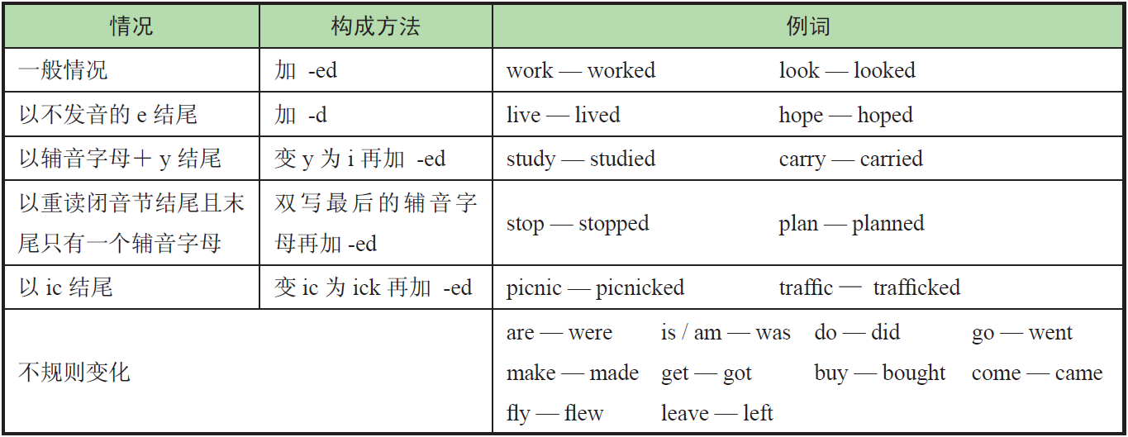2 Ask the students to finish the exercises.
3 Check the answers.
Assignments
- 100% of students grasp what is the past tense.
- 80% of students know how to use the past tense correctly.
- 60% of students can Distinguish between simple present and simple past tense correctly.

Part Ⅴ Applied Writing

Steps
1 Explain the method of writing a letter of thanks in accordance with the sample.
感谢信是一种表达感谢的私人或公务信函。感谢信一般要开门见山表明写信意图——感谢，然后重点详述感谢缘由，最后再次致谢。感谢信要做到感情真挚，语气恳切。
- Explain the useful expressions in writing.
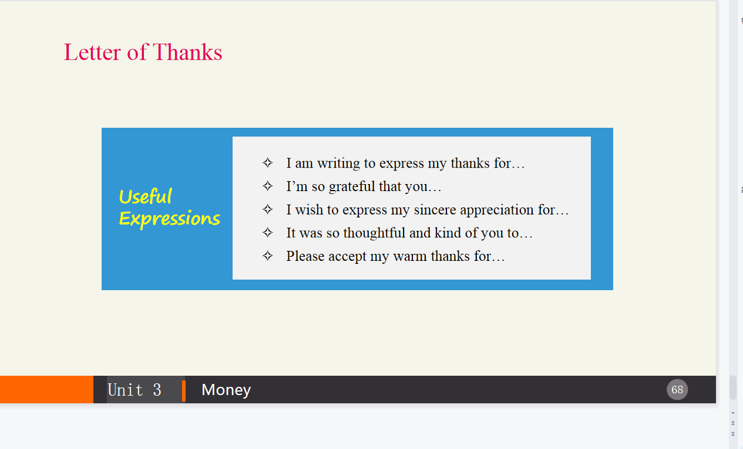
- Ask the students to finish the exercise and make comments.
Assignments
- 100% of students can get the main points in a letter of thanks.
- 80% of students can write a letter of thanks required independently.

Period 4

Part Ⅵ Watching & Performing

Steps
1 Introduce the movie and then play the clip.
《一个购物狂的自白》是一部美国浪漫喜剧电影。主人公Rebecca是一个购物狂，在没有工作的情况下还要为支付不起的巨额债务苦苦挣扎。一次醉酒后寄出的邮件使得Rebecca被Alette杂志雇佣。与此同时，催债人Derek Smith一直追着Rebecca要债。当她的专栏成功时，Rebecca被邀请做一场直播。在直播现场，她的谎言、对奢侈品的痴迷、信用卡的滥用被拆穿后，她失去了观众、朋友以及Luke。经历了这些之后，Rebecca重新树立了她的个人理财观念，卖掉了所有的奢侈品并且偿还了所有债务，并重获爱情、友情和观众。这部电影想告诉年轻人要合理并且理性地使用自己手中的信用卡，树立正确的个人理财及消费观念。
2 Ask the students to imitate the movie clip.
3 Ask the students to make their own dialogues in given situations and invite others to score for them.
思政拓展：影片中丽贝卡的“购物狂”形象具有普遍性意义。购物是女性发泄情绪的一种方式，能让女性心情变好。但凡事过犹不及，如果购物成瘾，影响了正常生活就得不偿失了。
好在贝丽卡最终悬崖勒马醒悟过来，她卖掉了所有的奢侈品，还清所有卡债，挽回了爱情和友谊，回归到生活的正轨。这就是电影《一个购物狂的自白》给我们的启示和意义所在。



https://baijiahao.baidu.com/s?id=1693893479907273860&wfr=spider&for=pc

