Unit 2 Valuable Friendship
“海内存知己，天涯若比邻”强调了友谊是心灵的需要。友情是一种重要的精神需要，离开了朋友，失去了友谊，人就会感到孤独。进入少年期后，我们更愿意向同龄伙伴特别是亲密朋友倾诉心事，真挚的友谊是人生最宝贵的财富。学校是一方充满了浓郁文化气息的净土，我们更应培养和树立学生正确的友情观，为和谐校园、团结友爱、互帮互助的校园奠定坚实的基础。

Unit Objectives
- Knowledge and skill（知识、技能目标）:
Students should know how to describe a friend, and get to know what friendship is
Students should acquire the new words and expressions.
Students should grasp the grammar of adjectives and adverbs.
Students should master how to write notice and announcement.
- Feeling, attitudes, and values（情感、态度和价值观目标）:
Students should know the preciousness of friendship and cherish it.
- Ideological and Political Aims（思政目标）
Students should know what is valuable friendship.
Students should know how to cultivate right values on making friends.
Enable students to cherish valuable friendship and create a harmonious, friendly and united campus.

Teaching Important Points
1 Master the following words and phrases:
handle, competition, consider, recognize, peer, explain, stress, rely, common, complain, owe, repay, absence, manage, survive, celebrate, bless, apart, depend, outlast, manage to do, remind sb. of, depend on find out, reach out, make sure
2 Ask the students to grasp how to introduce their friends to others.
3 Grasp the grammar of adjectives and adverbs.
4 Enable the students to understand what is friendship and help them recognize the preciousness of friendship and cherish it.

Teaching Difficult Points
1 Improve the students’ ability of guessing the meaning of words by means of word formation.
2 Ask the students to grasp how to write notice and announcement.

Teaching Arrangement

Period 1: Lead-in, listening and Speaking
Period 2: Reading
Period 3: Grammar, Applied Writing
Period 4: Watching and Performance

Teaching Approach
Tasked-based; Group work；Online learning

Teaching Procedures

Period 1

Part Ⅰ Lead-in
Exercise Ⅰ(steps) | Exercise Ⅱ(steps) | Exercise Ⅲ (steps)
1.Provide some information to lead students to the topic “Friendship”. The teacher may invite some students to share their opinions about their friends.  www.iqiyi.com/v_19ryki6ifc.html  经典咏流传 那些诗词中令人羡慕的友情，撒贝宁说给你听...  2.Play the video in the textbook twice and let students grasp the sentence “The guy who ......” to describe the friends they like. | 1.Read and explain the sentences in the table below.  2.Set aside some time for students to work in groups to talk about their opinions on  “What is friendship?”.  3.Invite some students to state their opinions on the topic by using these expressions. | - Lead the students to appreciate the poem, and introduce the background information about this poem.  - Ask the students to read the poem given in the textbook.

思政拓展：李白杜甫传颂千古的友谊
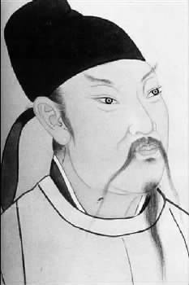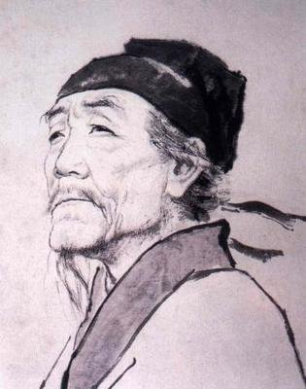
李白与杜甫是两位伟大的诗人，一个为浪漫主义大师，一个为现实主义巨擘，分别有“诗仙”和“诗圣”的美誉，是中国文学史上熠熠生辉的双子星座。他们人生中的第一次洛阳相会，更成为后人的千古美谈。（https://article.xuexi.cn/articles/index.html?art_id=13190763173161516175&t=1617956861079&showmenu=false&study_style_id=feeds_default&source=share&share_to=copylink&item_id=13190763173161516175&ref_read_id=4963f8a6-442e-45a7-a172-402a450fd431_1630202254371）

*Exercise II
* A friend is somebody you like spending time with.  朋友是你喜欢共度时光的人。 | * Friends help each other in lots of ways.  朋友之间总是用各种方式去帮助对方。
* You can be friends with more than one person.  你可以交不止一个朋友。 | * A true friend is there when you call.  真正的好朋友，总是随叫随到。
* A true friend can make you smile on your worst days.  真正的朋友总是让你在最糟糕的时候也能露出微笑。 | * It is a very lucky thing to have true friends.  拥有挚友是一件非常幸运的事。
* Your friends can be friends with other people as well, not just with you.
你的朋友也可以跟其他人成为好朋友，而不仅仅是你的朋友。

Assignments
- 100% of students should grasp the sentence “The guy who ......” to describe the friends they like; at least 3 sentences in Exercise II and appreciate the poem in Exercise Ⅲ.
- 60% of students should grasp the knowledge in the three Exercises.
- 30% of students can make more sentences based on the knowledge they have learned; they can search for more information about friendly and share with classmates.

Part Ⅱ Listening and Speaking

Exercise I

Steps
1 Lead the students to read the new words and expressions and explain their meanings.
2 Let the students listen to the recording twice, and then fill in the blanks.
3 Check the answers.

Words and Phrases
quality /ˈkwɒləti/ n. 品质；美质，优点，素养
different kinds of 不同种类
get on well 相处得好
get sb. wrong 误会，误解，曲解（某人的意思）；关系融洽
have sth. in common 有共同之处
maintain /meɪnˈteɪn/ v. 保持；保养；坚持
consideration /kənˌsɪdəˈreɪʃn/ n. 考虑，考察；照顾，关心；尊敬
vital /ˈvaɪtl/ adj. 维持生命所必需的；至关重要的；生死攸关的
figure out 计算出；弄明白；解决；想出

1

4

Steps
1 Explain the useful expressions about how to introduce a friend.
*He / She is… years older / younger than me.  他/她比我大/小几岁。 | * We meet in the… class.  我们是在……节课上认识的。
* He / She sits next to me.  他/她就坐在我旁边。 | * We both interested in…  我们都对……感兴趣。
* He / She is a / an… person.  他/她是个……样的人。 | * We can share our thoughts about…  我们可以分享关于……的看法。
* He/ She helps me when I am in trouble.  他/她经常在我需要的时候帮助我。 | * We both like eating.  我们都喜欢吃。
* I think we can get on well with each other.  我觉得我们可以很友好地相处。 | * Friends should give each other a hand whenever they need.  无论何时，朋友都应该相互帮助。
2 Play the sample dialogue twice.
3 Set aside some time for students to work in groups to organize their own scene according to the given situation and sample dialogue.
4 Invite one or two groups to perform their scene.

Assignments
- 100% of students know how to introduce oneself and their friends to others (录音或视频).
- 70% of students be able to describe a friend and say something about friendship(录音或视频).

Exercise Ⅲ

Steps
1 Introduce the song simply and let the students enjoy it.
《I Will Come to You》是美国创作型乐队Hanson在1997年推出首张专辑《Middle of Nowhere》中的一首歌曲。大众汽车国内首支品牌形象广告片的音乐采用的便是这首歌。经过了三十年，这首歌仍不断被人传唱，可见它的魅力。
- Ask the students to fill in the blanks and check the answers.

Period 2

Part Ⅲ Reading
Teaching Focus
 | Text A Intensive Reading | Text B Extensive Reading
Theme | Friendship | A Letter to a Best Friend
Words and Phrases | handle, competition, consider, recognize, peer, explain, stress, rely, common, complain,  find out, reach out, make sure | owe, repay, absence, manage, survive, celebrate, bless, apart, depend, outlast, manage to do, remind sb. of,  depend on
Text A Intensive Reading

Pre-Reading Discussions
This text mainly illustrates how the author gets on with his / her classmates. College life is a cooperative not competitive life. The author learnt that the importance of friendship in college life, and enjoyed it a lot. Lead the students to the text by asking the pre-reading questions:
Do you compete with your classmates at college?
Do you think study breaks are important? Why?

Text Structure
Parts | Paras. | Main Ideas
One | Paras. 1~3 | The moments spent together with friends and taking study breaks together.
Two | Paras. 4~6 | How do I cooperate with my classmates.
Three | Para. 7 | The value of study groups and making friends.

Detailed Study
1 How do you handle the competition with other students? (Para. 1)
handle /ˈhændl/ v. to deal with a situation, a person, an area of work or a strong emotion
处理，应付（局势、人、工作或感情）
e.g. She’s very good at handling her patients. 她对待病人很有办法。
competition /kɒmpəˈtɪʃn/ n. a situation in which people or organizations compete with each other for sth. that not everyone can have 竞争；角逐
e.g. We won the contract in the face of strong competition .
面对激烈的竞争，我们赢得了这份合同。
compete with… 与……竞争
e.g. Charles has never felt the need to compete with anyone.
查尔斯从未感到有与任何人竞争的必要。
思政拓展：竞争与合作
（https://www.xuexi.cn/lgpage/detail/index.html?id=1314959244337229576）

2 I considered the greatest competition with other students was who can spend their Crimson Cash in the best way until the last week of the freshman year. (Para. 2)
consider /kənˈsɪdə(r)/ v.
(a) to think of sb. / sth. in a particular way 认为；以为；觉得
e.g. This award is considered (to be) a great honor. 这项奖被视为极大的荣誉。
(b) to think about sth. carefully, especially in order to make a decision （尤指为作出决定而）仔细考虑，细想
e.g. She considered her options. 她仔细考虑了自己的各种选择。
freshman /ˈfreʃmən/ n. a student who is in his or her first year at a university or college, or in the ninth grade at school （大学）一年级新生；（中学）九年级
e.g. He is a freshman in the department of law. 他是法律系的大一新生。
3 I recognized before even stepping onto campus that I didn’t want to compete with my peers and I was happy to find out that neither did most of my classmates. (Para. 3)
recognize /ˈrekəgnaɪz/ v. to know who sb. is or what sth. is when you see or hear them, because you have seen or heard them or it before 认识；认出；辨别出
e.g. I recognized him as soon as he came in the room. 他一进屋我就认出了他。
step onto 走上；踏上
e.g. You have to watch it when you step onto the ice! 你走上冰面时要留神了!
peer /pɪə(r)/ n. a person who is the same age or who has the same social status as you 身份（或地位）相同的人；同龄人；同辈
e.g. She enjoys the respect of her peers. 她受到同侪的尊敬。
4 I think of college life as cooperative, not competitive. I can always reach out to my friends for help and they explain things to me in ways I understand since they know me really well. (Para. 3)
cooperative /kəʊ'ɒpərətɪv/ adj. involving doing sth. together or working together with others towards a shared aim 合作的；协作的；同心协力的
e.g. Cooperative activity is essential to effective community work.
要把社区工作做好，协作活动是必不可少的。
reach out to sb. to show sb. that you are interested in them and /or want to help them
表示对某人感兴趣；表示愿意提供援助
e.g. The church needs to find new ways of reaching out to young people.
教会需要寻找新途径来为年轻人提供帮助。
explain /ɪkˈspleɪn/ v. to tell sb. about sth. in a way that makes it easy to understand 解释；说明；阐明
e.g. First, I’ll explain the rules of the game. 首先我要说明一下游戏规则。
5 One of my favorite things about college is living and working with my friends. Even when we’re cramming the night before a midterm, we don’t let each other get too stressed out and always make sure to take study breaks. (Para. 3)
favorite /ˈfeɪvərɪt/ adj. liked more than others of the same kind 特别受喜爱的
e.g. It’s one of my favorite movies. 这是我特别喜欢的电影之一。
cram /kræm/ v.
(a) (rather old-fashioned) to learn a lot of things in a short time, in preparation for an exam （为应考）临时死记硬背
~ for sth.
e.g. He’s been cramming for his exams all week.
他整个星期都一直在拼命准备应考。
(b) to push or force sb. / sth. into a small space; to move into a small space with the result that it is full 把……塞进；挤满；塞满
e.g. He crammed eight people into his car. 他往他的车里硬塞进八个人。
stress /stress/
n. pressure or worry caused by the problems in sb.’s life 精神压力；心理负担；紧张
e.g. Things can easily go wrong when people are under stress.
人在压力之下，办事情就容易出差错。
v. to emphasize a fact, an idea, etc. 强调；着重
e.g. He stressed the importance of a good education.
他强调了接受良好教育的重要性。
stress out 过度劳累，紧张
e.g. Set aside 30 minutes or more and be kind to your body and mind by letting the tensions and stress out.
预留出30分钟或更多的时间，善待自己的身体和心灵，让紧张和压力远离自己。
make sure 把事情弄清楚，核实或查明某事物；设法确保出现某事物；务使
e.g. They want to make sure the newcomers don’t get a look-in.
他们不想让新人有露脸的机会。
6 There’s something about taking study breaks to drink hot chocolate after every practice exam we worked on together that strengthens our friendships. (Para. 4)
strengthen /'strɛŋθn/ v. to become stronger; to make sb./sth. stronger 加强；增强；
e.g. Her position in the party has strengthened in recent weeks.
最近几个星期以来，她在党内的地位有所增强。
7 It also comes in handy having friends to rely on for pep talks during midterms week or long problem sets. (Para. 4)
rely /rɪˈlaɪ/ v. to need or depend on sb./ sth. 依赖；依靠
rely on / upon sb. / sth.
e.g. As babies, we rely entirely on others for food.
在婴儿时期，我们完全依赖别人喂食。
pep talk 激励的话；鼓舞士气的话
e.g. The coach gave the team a pep talk before the big game.
大赛之前，教练向队员讲话,给他们打气。
come in handy 有用处；迟早有用
e.g. The extra money came in very handy. 这笔额外的钱正好派上了用场。
8 As a sophomore, I see my friends around even more. In my global health class, I was excited to see so many friends. I catch the morning shuttle to class with my friends and our schedules line up so I usually have lunch with a few of them, too. Since most of us live within two minutes of one another, it’s easy to find a common room or table in the dining hall to take over at 9 p.m. for studying. (Para. 5)
sophomore /ˈsɒfəmɔː(r)/ n. a student in the second year of a course of study at a college or university 大学二年级学生
e.g. He is in his sophomore year. 他在读二年级。
shuttle /ˈʃʌtl/ n. a plane, bus or train that travels regularly between two places 来往于两地之间的航班（或班车、火车）
e.g. a shuttle service between London and Edinburgh
往返于伦敦和爱丁堡之间的航班
schedule /ˈʃedjuːl/ n. a plan that lists all the work that you have to do and when you must do each thing 工作计划；日程安排
e.g. I have a hectic schedule for the next few days. 我今后几天的日程紧得要命。
common /ˈkɒmən/ adj. happening often; existing in large numbers or in many places 常见的；通常的；普遍的
e.g. Jackson is a common English name. 杰克逊是常见的英语人名。
9 While college students definitely know the importance of learning and getting our work done, we also know that it’s important to enjoy yourself and have fun with friends. (Para. 6)
definitely /ˈdefɪnətli/ adv. (informal) a way of emphasizing that sth. is true and that there is no doubt about it 肯定；没问题；当然；确实
e.g. I definitely remember sending the letter. 我记得这封信肯定发出去了。
importance /ɪmˈpɔːtns/ n. the quality of being important 重要性；重要；重大
e.g. She stressed the importance of careful preparation. 她强调了认真准备的重要性。
10 That’s why my study group has our ritual of ordering pizza and taking video game breaks or running to the dining hall to eat food. (Para. 6)
ritual /ˈrɪtʃuəl/
adj. done as part of a ritual or ceremony 仪式上的；庆典的
e.g. The goat was ritually slaughtered. 山羊按照仪式宰杀了。
n. a series of actions that are always performed in the same way, especially as part of religious ceremony 程序；仪规；礼节；（尤指）宗教仪式
e.g. She objects to the ritual of organized religion. 她反对有组织宗教的仪规。
11 While I might complain about my classes from time to time, I have them to thank for meeting such great friends. (Para. 7)
complain /kəmˈpleɪn/ v. to say that you are annoyed, unhappy or not satisfied about sb. / sth. 抱怨；埋怨；发牢骚
~ to sb. about / of sth.
e.g. I’m going to complain to the manager about this. 我要就这件事向经理投诉。

Assignments:
- Understand the passage and grasp the language points.
- Understand how to handle the relationship between friends.

Text B Extensive Reading
Steps
1 Lead the students to read the new words and phrases in Text B and explain their meanings.
2 Ask the students to read the questions in Reading Comprehension and then give them 15 minutes to read the text.
3 Ask the students to finish the exercises in Reading Comprehension.
4 Check the answers.

How to Use the Reading Skills:猜测词义（二）通过构词法猜测词义
Examples from Text B
1 You have been my therapist , partner , and sister for the last seventeen years and I need you to know that. （Para.1中therapist，是“药剂师”的意思，其中therap是一个医学名词，意思是“治疗的，治疗学的”，词根 -ist 是“……专业人员”，“……专家”，“从事……的人”的意思，组成复合词为“药剂师”的意思。）
2 You are my dearest friend and I can’t thank you enough for everything you have done for me throughout my life. （Para.7中through一词由though out 组成，through 是通过，穿过的意思，out是出来的意思。所以两个词合起来就是“自始至终；在……期间；遍及……地域；遍及……场所”的意思。)

Detailed Study
1 I owe 1 you my life. I am not sure how I can ever repay you for all that you have done for me but I need you to know what you mean to me. (Para. 1)
owe /əʊ/ v. to have to pay sb. for sth. that you have already received or return money that you have borrowed 欠（债）；欠（账）
~ sth. to sb. / ~ sb. sth.
e.g. She still owes her father £3,000. 她还欠她父亲3 000英镑。
She still owes £3,000 to her father. 她还欠她父亲3 000英镑。
2 You have been my therapist, partner, and sister for the last seventeen years and I need you to know that because our lives have grown separately does not mean I need you any less. You were with me during the greatest moments of my life and took care of me through the worst. (Para. 1)
partner /ˈpɑːtnə(r)/ n. the person that you are married to or having a sexual relationship with 配偶；伙伴
e.g. Come to the New Year disco and bring your partner!
携伴来参加新年迪斯科舞会吧！
separately /ˈseprətli/ adv. as a separate person or thing; not together 单独地；分别地
e.g. They were photographed separately and then as a group.
他们先单独照相，然后合影。
3 You are the person whose absence would leave a huge gap in my life. (Para. 1)
absence /ˈæbsəns/ n. the fact of sb. being away from a place where they are usually expected to be; the occasion or period of time when sb. is away 缺席；不在
~ from… 缺席……
e.g. The decision was made in my absence . 这个决定是我不在的时候做出的。
absence from work 缺勤
gap /gæp/ n. a period of time when sth. stops, or between two events 间断；间隔；间隙
e.g. Leave a gap between your car and the next. 在车与车之间留条道。
4 Seventeen years ago we met. Over those years, we have managed to survive our middle school years, trying to find ourselves in high school and our first efforts at “adulting” in college. (Para. 2)
manage /ˈmænɪdʒ/ v. to succeed in doing sth., especially sth. difficult 完成（困难的事）；勉力完成
e.g. We couldn’t have managed without you. 没有你，我们就办不成了。
Language Point
manage sth.
e.g. Can you manage another piece of cake? 你还能再吃块蛋糕吗？
manaage to do sth. 设法做……
e.g. We managed to get to the airport in time. 我们设法及时赶到了机场。
survive /səˈvaɪv/ v.
(a) to continue to live or exist 生存；存活；继续存在
~ from sth. ……中存活下来
e.g. Some strange customs have survived from earlier times.
有些奇怪的风俗是从早年留存下来的。
(b) to continue to live or exist despite a dangerous event or time
幸存；幸免于难；艰难度过
e.g. Many birds didn’t survive the severe winter. 很多鸟死于这次严冬。
(c) to live or exist longer than sb. / sth. 比……活（或存在）的时间长
e.g. She survived her husband by ten years. 丈夫死后她又活了十年。
5 But more importantly we have survived first loves, celebrated great successes, and outlasted every other friendship we have ever had. (Para. 2)
celebrate /ˈselɪbreɪt/ v. to show that a day or an event is important by doing sth. special on it 庆祝；庆贺
e.g. Jake’s passed his exams. We’re going out to celebrate.
杰克已通过考试，我们要外出庆祝一下。
outlasted /autˈlɑːstid/ v. to continue to exist or take part in an activity for a longer time than sb. / sth. 比……持续时间长
e.g. He can outlast anyone on the dance floor. 在舞场上，他比谁都能跳。
6 My life is a mess in many ways. (Para. 3)
mess /mes/
n. a dirty or untidy state 肮脏；杂乱；不整洁
e.g. The room was in a mess. 这个房间杂乱不堪。
v. make untidy 使不整洁
e.g. Careful — you’re messing my hair. 小心——你弄乱我的头发了。
7 I am crazy, embarrassing and sometimes I don’t even know what to do, but you always do. Even now when we live apart, you still manage to be the person that I can always turn to. It is always you that is on the other end of the phone. (Para. 3)
embarrassing /ɪmˈbærəsɪŋ/ adj. making you feel shy, awkward or ashamed 使人害羞的（或难堪的、惭愧的）
e.g. It was so embarrassing having to sing in public.
非得在众人面前唱歌太令人难为情了。
manage to do sth. 设法做成某事
e.g. How do you manage to do such a thing? 你是怎么设法做这样的事?
turn to（使）转向；（使）变成；求助于；翻书到
e.g. There was no one to turn to, no one to tell. 没人可以求助，没人可以诉说。
in turn 依次；轮流；逐个
e.g. The children called out their names in turn. 孩子们逐一自报姓名。
8 I continue to be blessed to have been able to survive college with you as well. (Para. 4)
bless /bles/ v. to ask God to protect sb. / sth. 求上帝降福于；祝福
e.g. They brought the children to Jesus and he blessed them.
他们把孩子带到耶稣跟前，耶稣祝福了他们。
be blessed with sth. / sb.
e.g. She’s blessed with excellent health. 她身体很好，是一种福气。
9 Four years ago, when we said goodbye I was scared we would drift apart. The thought of being apart for four years terrified me. (Para. 4)
scared /s'kɑːrd/ adj. frightened of sth. or afraid that sth. bad might happen 害怕；恐惧；畏惧；担心
~ of sb. / sth. / ~ of doing sth. /~ to do sth. / ~ that…
e.g. She is scared of going out alone. 她不敢一个人外出。
People are scared to use the buses late at night. 人们害怕在深夜乘坐公共汽车。
I’m scared that I’m going to fall. 我担心自己快掉下去了。
drift /drɪft/
n. a slow steady movement from one place to another; a gradual change or development from one situation to another, especially to sth. bad 流动；趋势；逐渐变化（尤指向坏的方面）
e.g. The drift of the icebergs in the sea endangers the ships.
海上冰山的漂流危机船只的安全。
v. to move along smoothly and slowly in water or air 漂流；漂移；飘
e.g. Clouds drifted across the sky. 朵朵浮云在空中飘过。
terrify /ˈterɪfaɪ/ v. to make sb. feel extremely frightened 使恐惧；使十分害怕；使惊吓
e.g. Flying terrifies her. 她害怕坐飞机。
terrifying 令人害怕的
e.g. It was a terrifying experience. 那是一次可怕的经历。
at the thought of... 一想到……（就）
e.g. He was frightened at the thought of his coming exam.
一想到即将到来的考试他就害怕。
10 You have been my life’s constant. (Para. 5)
constant /ˈkɒnstənt/
n. a number or quantity that does not vary 常数；常量
e.g. The weather is a constant topic of conversation in Britain.
在英国，天气是交谈中永恒的话题。
adj. happening all the time or repeatedly 连续发生的；不断的；重复的
e.g. Babies need constant attention. 婴儿一刻也离不开人。
11 While everything around me is getting crazier by the second, you have been there to keep me grounded and remind me of who I am. (Para. 5)
grounded /ˈgraʊndɪd/ adj. having a sensible and realistic attitude to life （对生活）持有合理和现实态度的
e.g. Away from Hollywood, he relies on his family and friends to keep him grounded.
离开好莱坞之后，他靠家人和朋友使自己保持平衡心态。
remind /rɪˈmaɪnd/ v. to help sb. remember sth., especially sth. important that they must do 提醒；使想起
~ sb. about / of sth.
e.g. You remind me of your father when you say that.
你说这样的话，使我想起了你的父亲。
12 You will forever be my person to call in an emergency, depend on in times of need and just look to for some joy. You are my dearest friend and I can’t thank you enough for everything you have done for me throughout my life. (Para. 5)
emergency /iˈmɜːdʒənsi/ n. a sudden serious and dangerous event or situation which needs immediate action to deal with it 突发事件；紧急情况
e.g. This door should only be used in an emergency . 这道门只能在紧急情况下使用。
depend /dɪˈpen/ v. be contingent upon (sth. that is ellided) 依靠；依赖；信赖；决定于
e.g. The cooking time needed depends on the size of the potato.
所需的烹饪时间取决于土豆的大小。
depend on / upon sb. / sth.
e.g. He was the sort of person you could depend on. 他这个人你是可以信赖的。
throughout /θruːˈaʊt/ prep.
(a) during the whole period of time of sth. 自始至终；贯穿整个时期
e.g. The museum is open daily throughout the year. 这个博物馆一年到头每天都开放。
(b) in or into every part of sth. 各处；遍及
e.g. They export their products to markets throughout the world.
他们把产品出口到世界各地的市场。
Assignments:
1. Know the skills and improve reading ability（思维导图）

Period 3

Part Ⅳ Grammar

Steps
- Explain what is adjective and what is the comparative form and superlative form of adjectives.
- Explain what is adverb and what is the comparative form and superlative form of adverb.
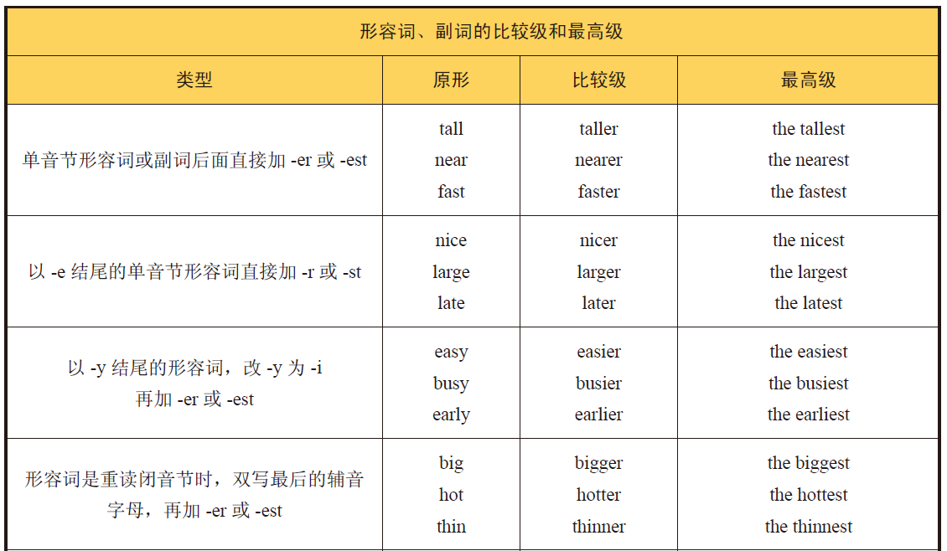
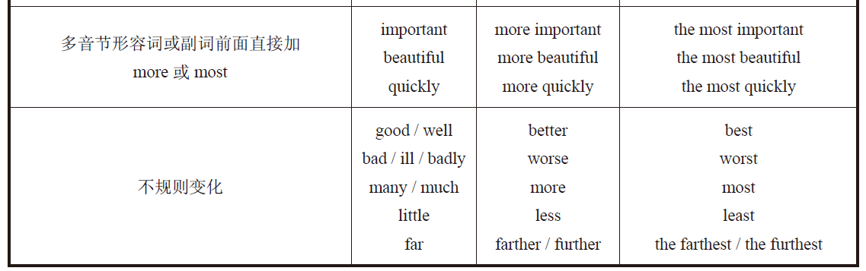
3 Ask students to finish the exercises.
4 Check the answers.

Assignments
- 100% of students grasp what are adjectives and adverbs.
- 80% of students know how to use adjectives and adverbs correctly.
- 60% of students can use the comparative form and superlative form of adjectives and adverbs correctly.

Part Ⅴ Applied Writing

Steps
1 Introduce the details and form of Notice / Announcement and in what circumstances they will be used.
A notice is an announcement containing information about a future event. Post a notice / announcement is to attract others attention.
- Explain the main points in Notice/ Announcement.
- Give some useful expressions to write a notice.
- Ask students to read the sample and write a notice required in the textbook independently.

Assignments
- 100% of students can get the main points in Notice/ Announcement.
- 80% of students can write a notice required independently.

Period 4

Part Ⅵ Watching & Performing

Steps
1 Introduce the main plot of the movie.
《牛仔裤的夏天》是根据畅销小说改编而成的，讲述了四个女孩在不可预知的成长过程中分享彼此的友谊、彼此鼓励迎接生活的故事。
四位挚友崔比、卡门、布丽奇特和莉娜度过了大学的第一学年，他们的暑期计划使整整分开了一年的她们在各自的道路上走得更远。她们将分别经历自由、爱情、选择和挑战的人生课程，各自走向成熟。而那条在她们中间传递的宝贵的牛仔裤则将他们的人生彼此联系起来，成为友谊的纽带。
由于母亲的全部注意力都放在即将降临的孩子身上，卡门感觉自己被替代了，而朋友们选择分开过暑假更让她感到失望。于是她接受了到弗蒙特担任戏剧节的幕后工作人员的工作邀请。在那里，她惊喜地发现自己被推向了群体的中心，与此同时成为了英俊的男主角注意的焦点。
崔比仍然在纽约为纽约大学的一个电影项目忙碌。她谨慎地使她与布莱恩的关系更进一步进入到。但对怀孕的担心和恐惧使她与布莱恩的关系陷入危机。而她选择面对一切。
对这四个好朋友来说，交流以前从来都是一件很容易的事情。现在，新情况地不断出现使保持联系变得没那么容易。有的时候，信息流失掉了或者被误解了。但是，当遇到最要紧、最重要的事，她们仍然是会帮助，守护彼此的人。
2 Play the movie clip.
3 Ask students to imitate the movie clip.
4 Ask the students to appreciate the lines from: Fast & Furious.

Watch the video “Eternal Friendship” after class and try to say something about what you get from the video in the discussion groups.
思政拓展：永恒的友谊
http://v.people.cn/n1/2019/0419/c176723-31038953.html 永恒的友谊--人民视频--人民网 (people.cn)
Watch the video “Eternal Friendship” after class and try to say something about what you get from the video in the online discussion groups.

