Unit 2 New Lifestyles

随着社会主义精神文明建设的深入进行，人们的生活方式和精神状态正在迅速发生变化。文明、健康、科学的生活方式，是大学生走向成功的基本素质。大学生群体作为时代文化的引领者，我们生活方式的变化反映着时代精神的变革。对大学生的生活方式问题进行探讨，引导他们形成健康文明的生活方式，已经成为高校思想政治教育和精神文明建设的一项重要任务。

Unit Objectives

- Knowledge and skill:
Students should be able to talk about new lifestyles and changes in modern society
Students should grasp the usage of present tense.
Students should acquire the new words and expressions.
Students should master the principle of invitation and reply.
- Feeling, attitudes, and values:
Students should be more creative and open-minded.
- Ideological and Political Aims（思政目标）
Students should know what does the healthy and civil lifestyle mean.
Students should know how to develop the healthy and civil lifestyle.
.

Teaching Important Points

1 Master the following words and phrases:
single, honestly, care about, possession, get rid of, essential, superficial, shift, content, used to, thumb, cram, necessity, estimate, dwarf, skeptical, low carbon
2 Enable the students to know about the new lifestyles.
3 Ask the students to grasp how to perform in the polite manners.
4 Grasp the grammar of present tense.

Teaching Difficult Points

1 Improve the students’ reading ability.
2 Ask the students to grasp how to send out invitation and reply to invitation.

Teaching Aids

A multimedia classroom
The blackboard

Teaching Approach

Tasked-based; Group work

Teaching Procedures

Period 1

Part Ⅰ Lead-in
1 Invite the students to discuss the items that they can’t live and lead them to the topic “New Lifestyles”.  2 Play the video twice and ask students to share the answers in group.  3 Explain new words and phrases. | 1 Allow the students to finish the exercise and check the answers.  2 Explain the new expressions in the exercise. | 1 Ask the students to match the phrases and then check the answers.  2 Explain the useful expressions and show more words.

Make a discussion: Youth can live without web?
拓展阅读：
离开网络看见更大的世界https://www.sohu.com/a/339984866_204104

当代年轻人现状，离开网络什么都不是

http://www.yidianzixun.com/article/0OK7KqY1?s=mochuang&appid=s3rd_mochuang&toolbar=&ad=&utk=

Exercise Ⅰ

Words and Phrases
1 express /ɪk'spres/ n. 特快列车；快递服务
v. 表达，表露
e.g. His views have been expressed in numerous speeches.
他已在无数次发言中表达了自己的观点。
2 online shop 网店
e.g. He finally realized his long harbored dream of opening an online shop.
他一直很想开个网店，今天终于如愿了。
online shopping 网上购物

Exercise Ⅱ

Words and Phrases
1 payment /'peɪmənt/ n. 付款；支付
mobile payment 手机支付
e.g. I gave ten pounds in payment for the goods I bought. 我买那些东西付了10英镑。
2 bored /bɔːd/ adj. 厌倦的；烦闷的
~ with sb. / sth.; ~ with doing sth.
e.g. The children quickly got bored with staying indoors. 孩子们在室内很快就烦了。
There was a bored expression on her face. 她脸上有一种厌倦的表情。
3 connect /kə'nekt/ v. （使）连接；联结
e.g. The towns are connected by train and bus services.
这些城镇由火车和公共汽车连接起来。

Exercise Ⅲ

Words and Phrases
online shopping 网上购物 mobile payment 手机支付
bike sharing 共享单车 low-carbon lifestyle 低碳生活方式
car pooling 拼车 electric car 电动汽车
express delivery 快递
Assignments
- 100% of students should grasp the words about new lifestyles in Exercise I and in Exercise Ⅲ.
- 60% of students should grasp the main ideas in the three Exercises.
- 30% of students can make more sentences based on the knowledge they have learned in the three Exercises.

Part Ⅱ Listening and Speaking

Exercise I

Steps
1 Explain new words and expressions in the table.
2 Play the dialogues twice and then ask students to fill in the blanks.
3 Check the answers.

Words and Phrases
1 nvenient /kən'viːniənt/ adj. 方便的；便利的
e.g. It is very convenient to pay by credit card. 使用信用卡付款非常方便。
A bicycle is often more convenient than a car in towns.
在城镇骑车常常比开车更方便。
2 simulate /sɪmjuleɪt/ v. 模仿；冒充
e.g. I tried to simulate surprise at the news.
听到这个消息，我竭力装出一副吃惊的样子。
［易混词］pretend /prɪˈtend/ v. 假装；伪装
e.g. We pretended (that) nothing had happened. 我们假装什么事情也没发生。
3 jam /dʒæm/ n. 许多人（或车辆）
traffic jam 交通拥堵
e.g. With the improvement of living standards of the people of China, the phenomenon of urban traffic jam is becoming more serious.
随着我国人民生活水平的不断提高，城市交通阻塞现象日趋严重。
4 account /ə'kaʊnt/ v. 认为；将……视作
e.g. I account myself well paid. 我认为我的报酬很优厚。
5 virtual /'vɜːtʃuəl/ adj. 虚拟的
Virtual Reality (VR) 虚拟现实（详见课本106页）
virtual machine 虚拟机
6 consuming habits 消费习惯
e.g. It’s a real revolution about people’s consuming habits.
这是人们消费习惯上的一场真正的革命。

Exercise Ⅱ

Steps
1 Explain the useful expressions about bike sharing.
* Bike sharing makes our life easier than ever.  * 共享单车让我们的生活更方便了。 | * But the troubles brought by the bikes shouldn’t be ignored (忽视).  * 但是一些自行车带来的问题也不容忽视。
* Users should cherish the bikes they are using.  * 使用过程中，用户应该好好爱惜单车。 | * With so many broken ones on the road, the convenience will turn into hidden trouble.  * 路上这么多破损的单车，导致便利变成了隐藏的麻烦。
* The companies need to…  * 公司应该…… | * Damages of the bikes are inevitable (不可避免的).  * 单车破损是不可避免的。
* Some users lock the bikes and take the bikes as their own things.  * 一些用户给单车上私锁，把车占为己有。 | * There are too many bikes available (可获得的) now.  * 现在有很多车可以用。
* If we all start to protect the bikes we are using, we will…  * 如果我们在使用时都可以保护单车，我们将会…… | * Bike sharing still needs a better supervision (监管).  * 共享单车仍然需要更有力的监管。
2 Encourage the students to make dialogues in given situations and invite some groups to perform.
3 Give the students more samples and make a short summary.

Assignments
- 100% of students can talk about the new lifestyles with their friends (录音或视频).
- 70% of students be able to describe a lifestyle they long for(录音或视频).

Exercise Ⅲ

Steps
1 Briefly introduce the song and invite the students to enjoy it.
《奇妙生活》（Amazing Life）由美国歌手布雷特·妮科尔演唱。歌曲传达了对美好生活的幸福感受和热爱。你准备好拥抱生活了吗？
2 Ask the students to fill in the blanks.
3 Check the answers

Period 2

Part Ⅲ Reading

Teaching Focus
 | Text A Intensive Reading | Text B Extensive Reading
Theme | Minimalism: Can Living with Less Make You Happier? | How to Get by in Beijing Without a Wallet
Words and phrases | single, honestly, care about, possession, get rid of, essential, superficial, shift, content, used to, thumb, cram | necessity, estimate, dwarf, skeptical, low carbon
Text A Intensive Reading

Steps
1 Lead the students to the topic and text.
2 Ask the students to read the text and analyze its structure.
3 Explain the details and language points of the text.
4 Ask the students to finish the exercises.

Pre-Reading Discussions
Text A tells what minimalism is and how it changes the author’s life. To lead students into the topic, the teacher is advised to draw the students’ attention to the following pre-reading questions:
Have you ever heard of “minimalism”?
What is your understanding of “minimalism”?
By doing this, the teacher may help the students see the structure of the text (for this see the next section “Text Structure”).

Text Structure
The text structurally goes like this: the author introduces himself first and then tells why he feels happy with his life and how he becomes a minimalist. Namely,

Parts | Paragraphs | Main Ideas
Part One | Paras. 1-2 | The author is an ordinary single adult man but minimalism makes him feel happy.
Part Two | Paras. 3-8 | Minimalism is such a lifestyle that gives the author a chance to be simple and happy and it totally changes my attitude towards life.
Part Three | Paras. 9-10 | The author says goodbye to past and learn about true happiness.

Detailed Study
1 I’m 35 years old, male, single, never been married. (Para. 1)
single /'sɪŋɡl/ adj.
(a) not married; not having a girlfriend or boyfriend 未婚的；单身的
e.g. It is difficult being a single mother. 做一个单身妈妈不容易。
(b) (a room) intended for one person to stay or live in 单人的
e.g. It is $65 for a single and $98 for a double.
单人间65美元一晚，双人间98美元一晚。
2 But I honestly don’t care about things like that anymore. (Para. 1)
honestly /'ɑnɪstli/ adv.
used to emphasize that what you are saying is true, however surprising it may seem 真的；确实
e.g. I honestly can’t remember a thing about last night. 我确实想不起昨晚的事了。
care about 关心；在乎
e.g. You don’t care about anything but yourself and your precious face.
除了你自己和那张娇贵的脸，你什么都不关心。
3 I got rid of most of my material possessions. (Para. 2)
got rid of to make yourself free of sb. / sth. that is annoying you 摆脱；丢弃
e.g. We got rid of all the old furniture. 我们扔掉了所有的旧家具。
I can’t get rid of this headache. 我的头疼老也不好。
思政拓展： 什么是断舍离的生活方式？
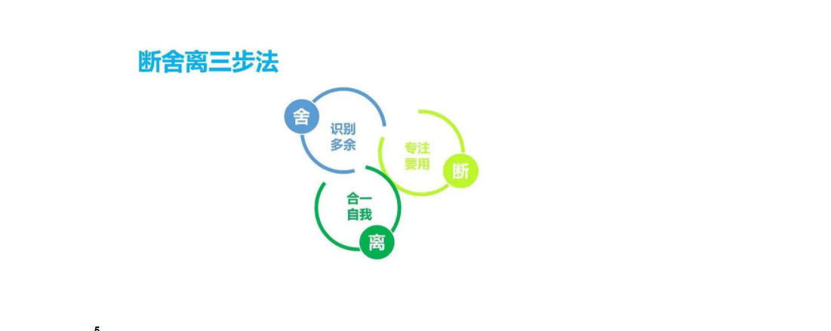
断舍离并非绝对要把房间收拾干净为目的，而是要通过收拾房间的过程了解和喜欢上自己，并实现自我肯定感。
https://www.douban.com/note/665076534/

possession /pə'zɛʃən/ n.
sth. that you own or have with you at a particular time 个人财产；私人物品
e.g. This ring is one of her most treasured possessions.
这只戒指是她最珍贵的财产之一。
4 Living with only the bare essentials has not only provided superficial benefits such as the pleasure of a tidy room or the simple ease of cleaning, but it has also led to a more fundamental shift. (Para.3)
essential /ɪ'senʃl/
adj. completely necessary; extremely important 完全必要的；必不可少的
e.g. Money is not essential to happiness. 金钱对于幸福并非必不可少。
n. sth. that is needed in a particular situation or in order to do a particular thing 必不可少的东西；必需品（意同Text B中的necessity）
e.g. The studio had all the essentials like heating and running water.
工作室里备有基本设施，如暖气装置和自来水。
superficial /ˌsuːpə'fɪʃl/ adj. (often disapproving) not studying or looking at sth. thoroughly; seeing only what is obvious 粗略的；肤浅的
e.g. The book shows only a superficial understanding of the historical context.
这部书表现出对历史背景肤浅的理解。
shift /ʃɪft/ n.
(a) a change in position or direction 改变；转移
e.g. fundamental shift 根本的改变
(b) a period of time worked by a group of workers who start work as another group finishes 轮班
e.g. to work an eight-hour shift 按每班八小时轮班工作
Language Point:
Living with only the bare essentials为现在分词做主语，谓语动词为单数。
5 I feel more content now than I ever did in the past. (Para. 4)
content /'kɒntent/
(a) n. the things that are contained in sth. 内容；所包含的东西
e.g. He tipped the contents of the bag onto the table.
他把包里的东西倒在桌上。
(b) adj. happy or satisfied 满意的；知足的
e.g. I’m perfectly content with the way the campaign has gone.
我对竞选活动的进展十分满意。
6 I used to buy a lot of things, believing that all those possessions would increase my self-worth and lead to a happier life. (Para. 5)
used to 过去时常
e.g. I used to live in London. 我过去住在伦敦。
Language Point:
believing that…为现在分词做伴随状语。其中that后的内容为believe的宾语。
7 Most I had thumbed through once or twice, thinking that I would read them when I had time. (Para.6)
thumb /θʌm/ v.
to touch or move sth. with your thumb 用拇指摸
e.g. She thumbed through the book on the shelf. 她翻阅了书架上那本书。
8 The closet was crammed with what used to be my favorite clothes. (Para. 7)
cram /kræm/ v.
to push or force sb. / sth. into a small space 把……塞进；塞满
be crammed with 塞满；堆满
e.g. The house is crammed with priceless furniture and works of art.
房子里摆满了昂贵的家具和艺术品
Text B Extensive Reading
Steps
1 Lead the students to read the new words and phrases in Text B and explain their meanings.
2 Ask the students to read the questions in Reading Comprehension and then give them 15 minutes to read the text.
3 Ask the students to finish the exercises in Reading Comprehension.
4 Check the answers.

How to Use the Reading Skills
精读是区别于泛读而言的概念，指深入细致地研读。一个人要积累知识，就必须读书。对重要的文章和书籍，要认真读反复读，要逐字逐句地深入钻研，对重要的语句和章节所表达的思想内容还要做到透彻理解，这就是精读。具体而言，可采用以下方法进行精读：
1 把经典论述的句子找出来
2 对书中的名词、概念加以界定（特别是一些关键的词）
3 对该书形成的背景（或理论产生的背景）应有所了解
4 归纳出基本观点和特征
5 把已经理解的东西用自己的语言复述一遍
6 写读后感

Detailed Study
1 No way to pay for food, transportation or any of life’s other necessities. (Para. 1)
pay for 为……付钱
e.g. I have had to pay for repairs to the house. 我不得不支付房屋维修费用。
necessity /nə'sesəti/ n. sth. that you must have in order to live properly or do sth. 必需品
e.g. Water is a basic necessity of life. 生命离不开水。
2 China’s fast-developing mobile commerce industry is estimated to dwarf that of the U.S., so I set out to see how far a phone would get me in the country’s capital.
(Para. 4)
estimate /'estɪmət/ v. to make an approximate judgment or calculation of it 估计；估价；估算
e.g. I estimate that the total cost for treatment will be $12,500.
我估计治疗费用总共有1.25万美元。
be estimated to 据估计……
dwarf /dwɔːf/ v. to make sth. seem small or unimportant compared with sth. else 使显得矮小；使相形见绌
e.g. The old houses were dwarfed by the huge new tower blocks.
这些旧房子在新建的高楼大厦的映衬下显得十分矮小。
3 Admittedly, I was a bit skeptical about going an entire day Beijing without my wallet, but I was surprised to discover just how easy and convenient it is. (Para. 5)
skeptical /'skeptɪkəl/ adj. having doubts about sth. 充满怀疑的
be skeptical about 对……表示怀疑
e.g. Others here are more skeptical about the chances for justice being done.
这里的其他人对正义能否得到伸张持更加怀疑的态度。
Language Point:
which will benefit our environment中，which引导的定语从句，修饰living style。其中，which在定语从句中作主语成分。

Assignments:
1. Know the skills and improve reading ability（思维导图）

Period 3

Part Ⅳ Grammar

Steps
1 Explain the definition and categories of English verb tense.
在英语中，时态由“时”和“态”构成。“时”主要有4个主要部分，即现在、过去、将来和过去将来；“态”也有4种，即一般、进行、完成和完成进行。将4个“时”和4个“态”组合在一起，就是时态的种类，共16种。详见表格：
时态 | 现在时 | 过去时 | 将来时 | 过去将来时
一般 | 一般现在时  do | 一般过去时  did | 一般将来时  ( will do)  (be going to do)  (shall do) | 一般过去将来时  would do
进行 | 现在进行时  be doing | 过去进行时  was / were doing | 将来进行时  will be doing | 过去将来进行时  ( would be doing)  (was / were going to do)
完成 | 现在完成时  have done | 过去完成时  had done | 将来完成时  will have done | 过去将来完成时  would have done
完成进行 | 现在完成进行时  have been doing | 过去完成进行时  had been doing | 将来完成进行时  will have been doing | 过去将来完成进行时  would have been doing
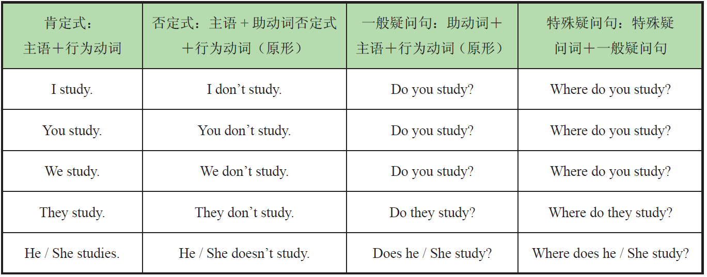
2 Ask the students to finish the exercises.
3 Check the answers.

Assignments
- 100% of students grasp what is simple present tense.
- 80% of students know how to use simple present tense.
- 60% of students can know the English verb tense .

Part Ⅴ Applied Writing

Steps
1 Explain the method of E-mail writing in accordance with the sample.
邀请函：是邀请亲朋好友或知名人士、专家等参加某项活动时所发的请约性书信。它是现实生活中常用的一种日常应用写作文种。在国际交往以及日常的各种社交活动中，这类书信使用广泛。一般包括以下内容：宾主姓名（被邀请人与邀请人姓名）、活动时间（具体到日、时、分）、内容、地点以及其他需要特别说明的内容。如果要求回复，请柬下方要用R.S.V.P.或RSVP（原为法语，意为：请赐复）。右下方是邀请人的电话号码。
回帖：被邀请人收到正式请柬后，应及时答复，以表示接受或拒绝。如果接受，应先表示谢意，然后再写明应邀出席的时间和地点；如果谢绝，应先致以歉意，然后再说明不能出席的原因。回帖的格式与请柬的格式相同。
- Explain the useful expressions in writing.
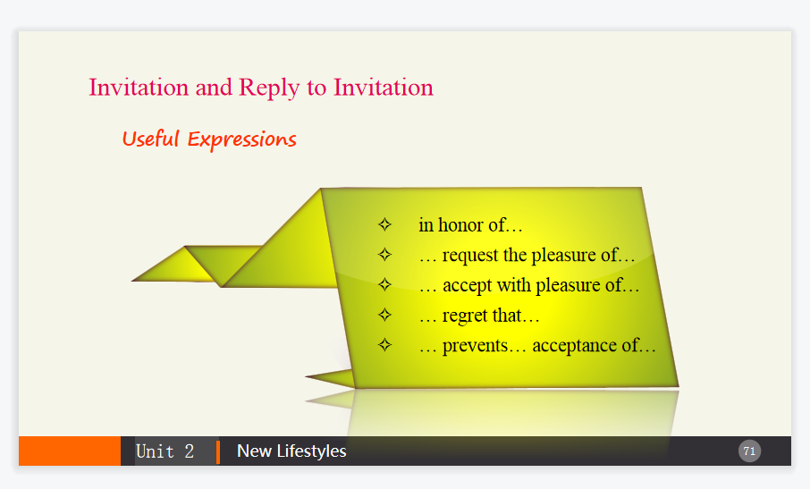
- Ask the students to finish the exercise and make comments.

Assignments
100% of students can get the main points in E-mail writing.
80% of students can write an E-mail required independently.

Period 4

Part Ⅵ Watching & Performing

Steps
1 Introduce the movie and then play the clip.
《超能陆战队》讲述的是发生在未来世界的超级都市旧京山的故事。热爱发明创造的天才少年Hiro，在哥哥Tadashi的鼓励下参加了Robert Callaghan教授主持的理工学院机器人专业的入学大赛。他凭借神奇的微型磁力机器人赢得观众、参赛者以及考官的一致好评。谁知突如其来的灾难却将Hiro的梦想和人生毁于一旦——大火烧毁了展示会场，而哥哥为了救出受困的Callaghan教授命丧火场。身心饱受创伤的Hiro闭门不出，哥哥生前留下的治疗型机器人Baymax则成为安慰他的唯一伙伴。原以为微型机器人也毁于火灾，但Hiro和Baymax意外发现有人在某座废弃工厂内大批量地生产微型磁力机器人。Hiro下定决心要把所有真相都弄清楚。在Baymax和朋友的帮助下，Hiro和怀有险恶阴谋的神秘对手展开较量，最终以自己的方式拯救了世界。
2 Ask the students to imitate the movie clip.
3 Ask the students to make their own dialogues in given situations and invite others to score for them.

