JJKD/C4/0701-3



**《**XXXXXXXXXXXX**》**

**教 案**

授课专业： 授课对象： 授课老师： 授课学期：

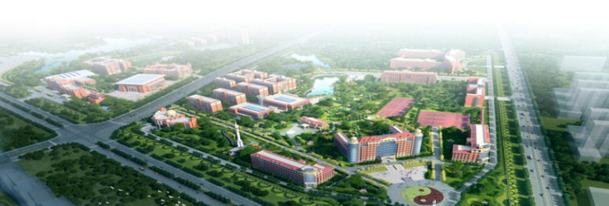

|  |
| --- |
| 班级学情分析 |

|  |  |  |  |
| --- | --- | --- | --- |
| **教学任务** |  | | |
| **计划学时** |  | **授课地点** |  |
|  | **素质目标** | **知识目标** | **能力目标** |
| **教学目标** |  |  |  |
| **教学重点** |  | | |
| **教学难点** |  | | |
| **教学内容** |  | | |

|  |  |  |
| --- | --- | --- |
| 教学策略 | **教学 组织** |  |
| **教学 方法** |  |

|  |  |  |  |  |  |  |
| --- | --- | --- | --- | --- | --- | --- |
| 教学策略 | **教学 资源** |  | |  | | |
| **教学实施过程** | | | | | |  |
| 教学环节 | 教学内容 | | 教师活动 | | 学生活动 |  |
| 课前导入 |  | |  | |  |  |
| 资 源 | | |  |
|  | | |  |

|  |  |  |  |  |  |
| --- | --- | --- | --- | --- | --- |
| 教学环节 | | 教学内容 | 教师活动 | 学生活动 |  |
| 课中 促学 |  |  |  |  | |
| 资 源 | | |
|  | | |

|  |  |  |  |  |  |  |
| --- | --- | --- | --- | --- | --- | --- |
| 教学环节 | | 教学内容 | 教师活动 | | 学生活动 | |
| 课中 促学 |  |  | | | | |
| 课后提升  课后作业 | |  | |  | |  |
| 教学反思与改进 | |  | | | | |